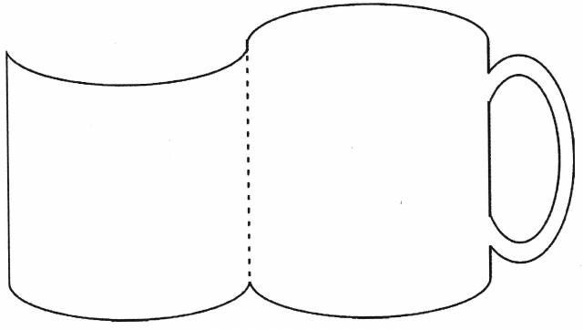

TEN

TWENTY



FORTY

THIRTY



SIXTY

FIFTY



EIGHTY

SEVENTY



ONE HUNDRED

NINETY

|  |  |  |  |  |
| --- | --- | --- | --- | --- |
| 10 | 20 | 30 | 40 | 50 |
| 600 | 70 | 80 | 90 | 100 |
| 10 | 20 | 30 | 40 | 50 |
| 600 | 70 | 80 | 90 | 100 |
| 10 | 20 | 30 | 40 | 50 |
| 600 | 70 | 80 | 90 | 100 |
| 10 | 20 | 30 | 40 | 50 |
| 600 | 70 | 80 | 90 | 100 |