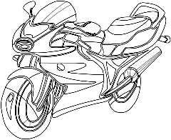
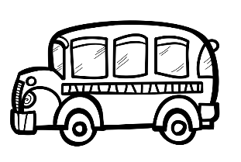
Zonguldak
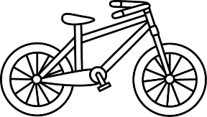
Giresun
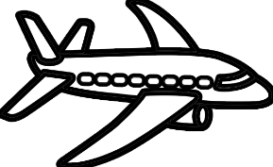
Amasya
Erzurum
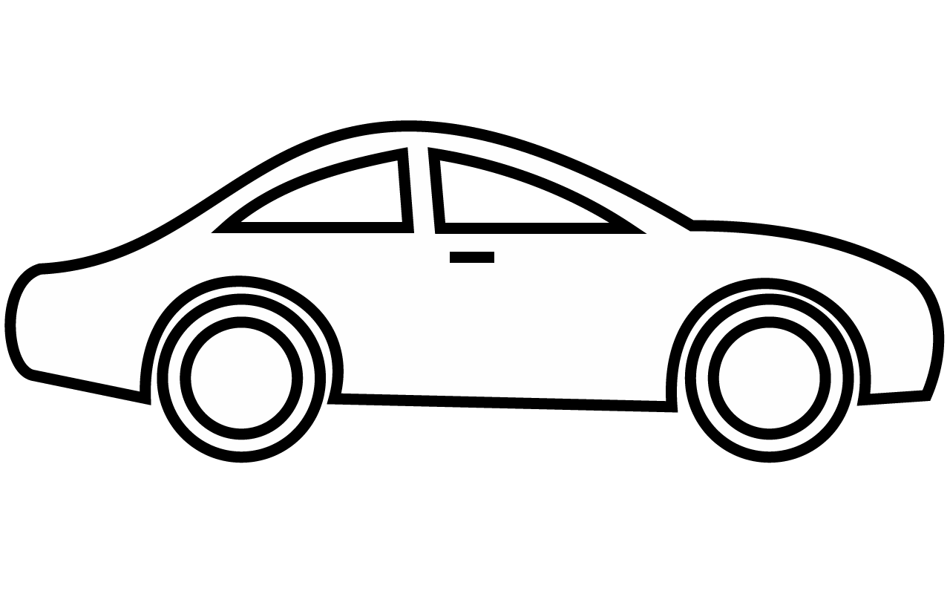
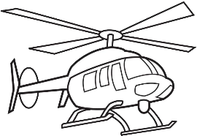
Ankara
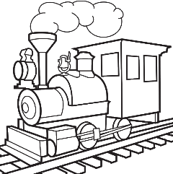
Aydın
Antalya
Diyarbakır
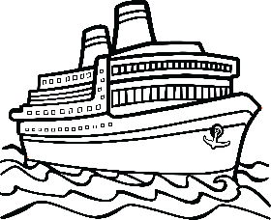
Adana

A: How can I go to Adana?  B: You can go by train. | A: How can you go to Diyarbakır?  B: I can take a helicopter. | A: How can I go to Antalya?  B: _______________________
A: How can you go to Giresun?  B: _______________________ | A: How can I go to Aydın?  B: _______________________ | A: How can you go to Amasya?  B: _______________________
A: How can I go to Erzurum?  B: _______________________ | A: How can you go to Zonguldak?  B: _______________________ | A: How can I go to Ankara?  B: _______________________

