**ZİYAEDDİN AKBULUT SECONDARY SCHOOL 5th GRADE 2nd TERM 1st ENGLISH EXAM**

**NAME/SURNAME: CLASS: 5/… NUMBER:**

**A)Boşlukları verilen kelimelerle doldurunuz.(5*3=15pts)**

**funny – frightening – movies** - **cartoon – tickets**

1) I have two ………………..for the film . Can we go to the cinema ?

2) What kind of …………………. do you like most ?

3) ‘Sünger Bob’ is a famous …………... character .

4) A horror film is ………………………. .

5) Cem Yılmaz is a ………………… person .He always makes me laugh.

**B)** **Boşlukları ‘should’ ya da ‘shouldn’t’ ile doldurunuz.(5*2=10pts)**

1. We ……………………… eat chips and chocolate.
2. We …………………….. eat fast food.
3. We ……………………... eat lots of fruits and vegetables
4. We …………………….. play computer games
5. We ……………………… have breakfast every morning.

**C)Kelimelerin rakamlarını resimlerin altına yazarak eşleştiriniz.(10*2=20pts)**

|  |  |  |  |  |
| --- | --- | --- | --- | --- |
| 1-Party hats | 2-clown | 3-guests | 4-balloons | 5-birthday cake |
| 6-invitation card | 7-present | 8-drinks | 9-music CDs | 10-candles |

    

1._____________ 2._____________ 3.___________ 4._________ 5.____________

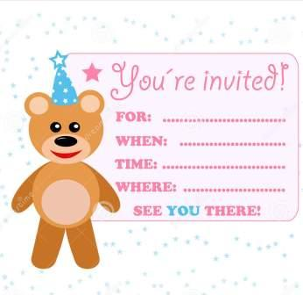    

6.____________ 7._______________ 8.____________ 9.___________ 10._________

[Belgeden bir alıntı veya ilginç bir noktanın özetini yazın. Metin kutusunu belge içinde herhangi bir yere konumlandırabilirsiniz. Kısa alıntı metin kutusunun biçimlendirmesini değiştirmek için Metin Kutusu Araçları sekmesini kullanın.]

**D)Eşleştiriniz.(5*2=10pts)**

|  |  |  |  |  |
| --- | --- | --- | --- | --- |
| **1** | **2** | **3** | **4** | **5** |
|  |  |  |  |  |

1. I have a sore throat. A. He should take a medicine.
2. She has a backache. B. You should see a dentist.
3. He has a headache. C. You should drink lemon and mint tea.
4. I have a toothache. D. He should wear your coat.
5. He has a cold. E. She shouldn’t carry heavy things.

**E) Mevsimlere göre ayları yazınız.(10*2=20pts)**

**April- May- January- July - March- August- November- June- February- September**

**AUTUMN(sonbahar**

**1-**

**2-**October

**3-**

**SPRING(ilkbahar)**

**1-**

**2-**

**3-**

**WINTER(kış)**

**1-**December

**2-**

**3-**

**SUMMER(yaz)**

**1-**

**2-**

**3-**

**F)Boşlukları ‘in-on-at’ ile doldurunuz.(5*2=10pts)**

1. My birthday is ______ 10th April.
2. Linda’s birthday is ______ summer.
3. I get up at 7 o’clock ______ the mornings.
4. My birthday party is ______ 8 o’clock.
5. You can go to the cinema ______ Friday.

**G)Aşağıdaki kelimelerin anlamlarını yazınız.(5*3=15pts)**

1. Horror film:____________
2. Documentary:____________
3. Western film:____________
4. Cartoon:____________
5. Comedy :____________

Good Luck ☺

Şerife ARSLAN