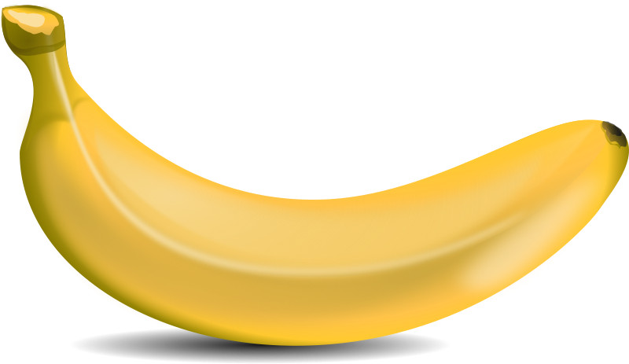

I am a BANANA

I am yellow

I am a yellow banana

[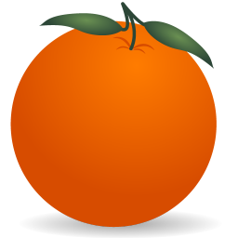](http://www.iconarchive.com/show/chinese-new-year-icons-by-gcds/orange-icon.html)

I am an ORANGE

I am orange

I am an orange orange



I am a WATERMELON

I am green

I am a green watermelon



I am an APPLE

I am red

I am a red apple

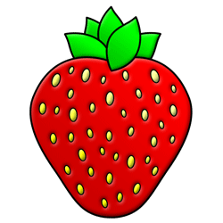

I am a STRAWBERRY

I am red and yellow

I am a red and yellow strawberry

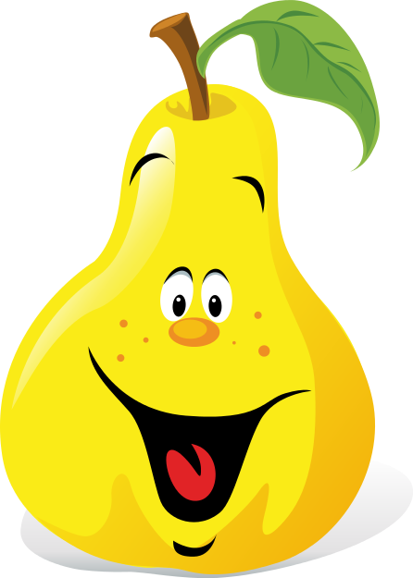

I am a PEAR

I am yellow

I am a yellow pear

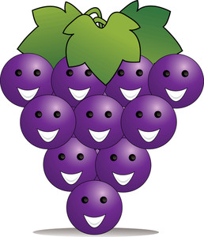

**We are GRAPES**

**We are purple**

**We are purple grapes**

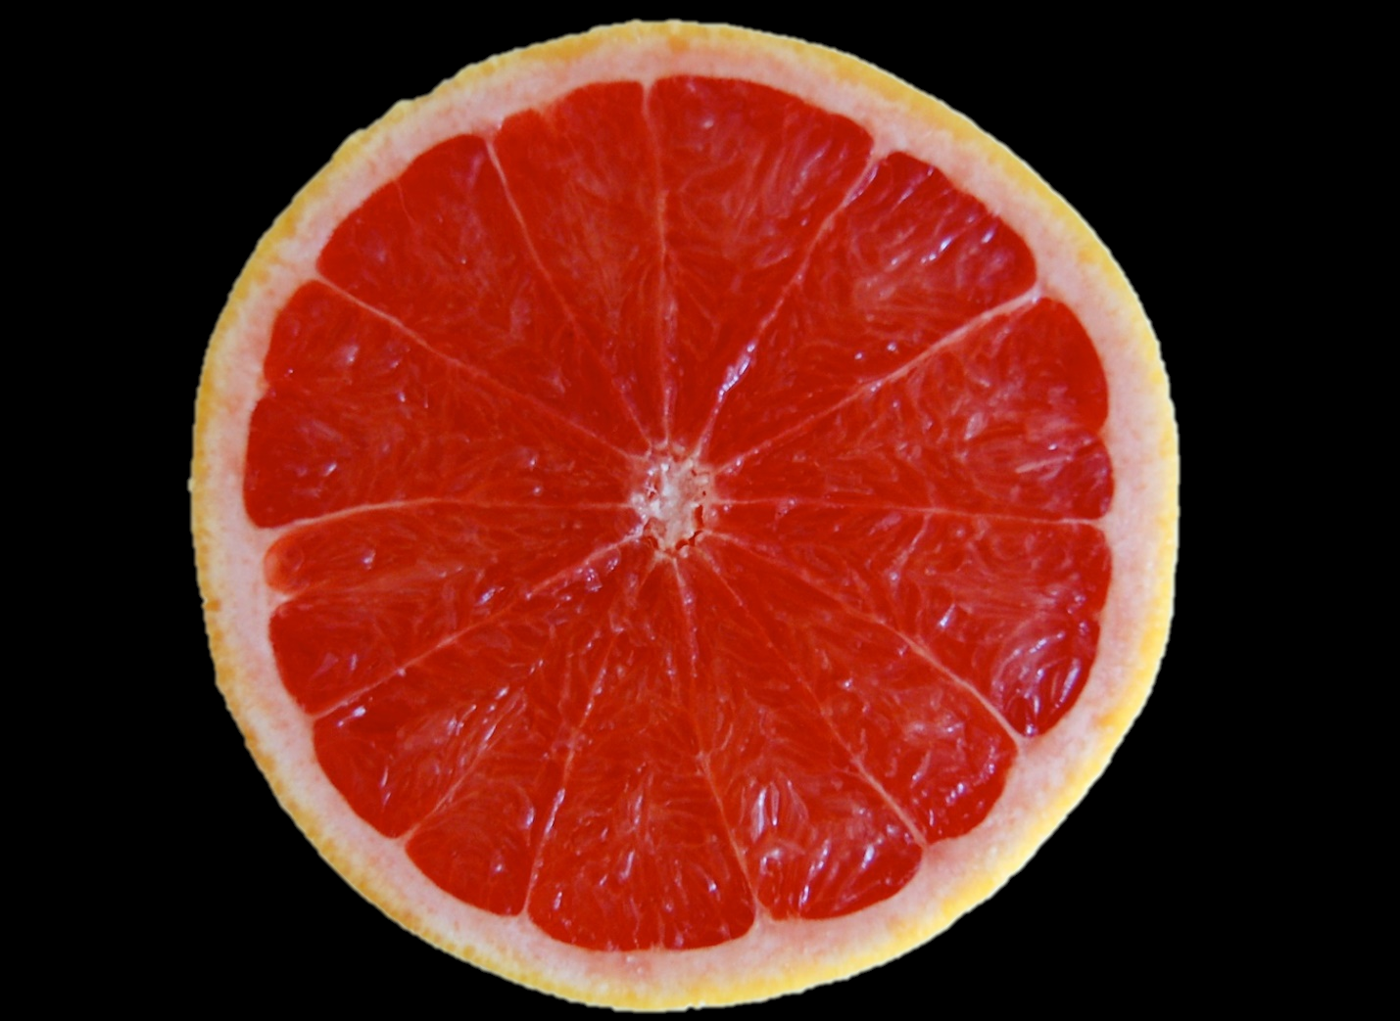

I am a GRAPEFRUIT

I am red

I am a red grapefruit

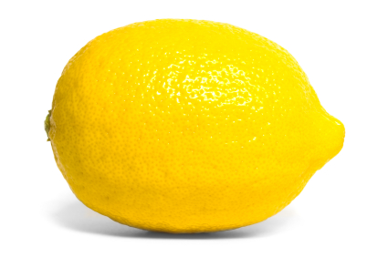

I am a LEMON

I am yellow

I am a yellow lemon

[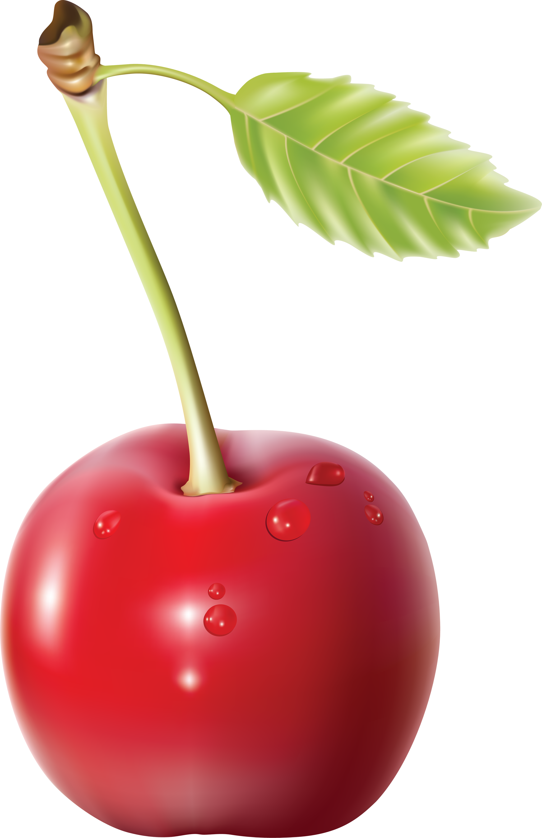](http://pngimg.com/upload/cherry_PNG3090.png)