**UNIT 9 - ENVIRONMENT - ÇEVRE 30 kelime**

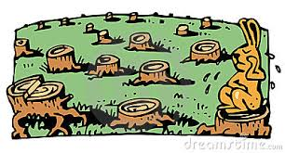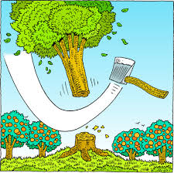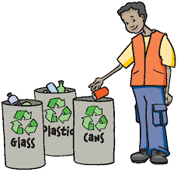air pollution - plant trees - save energy - river - earth - dislike - garbage - paper - public transport -protect - - lake - global warming - deforestation - sea life - keep clean - need - plastic bottle - increase -cut trees - greenhouse - glass - waste - forest - in danger - coal - wildlife - cycle - recycle - turn off - use

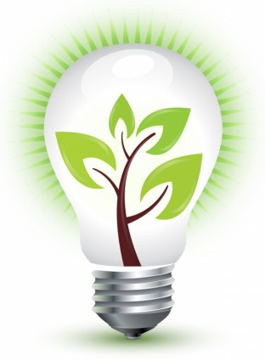

**1.**

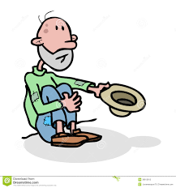

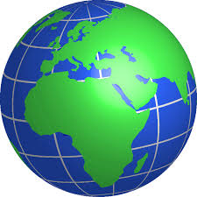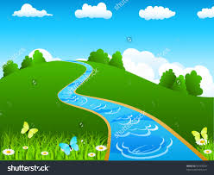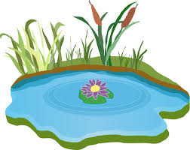

**6.**

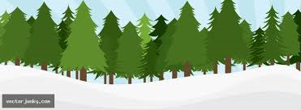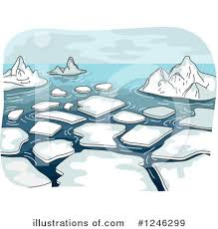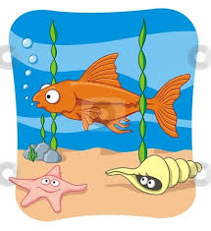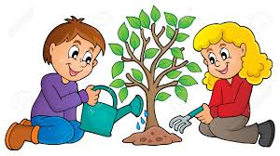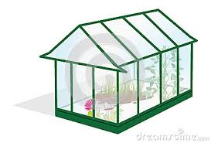

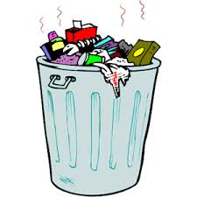

**11.**

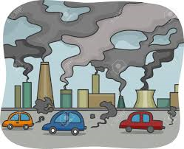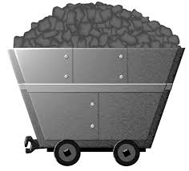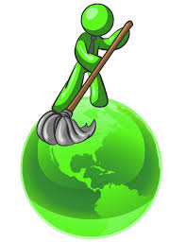

**16.**

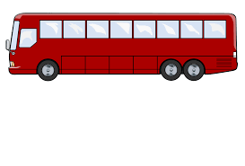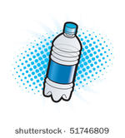

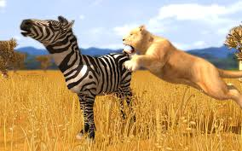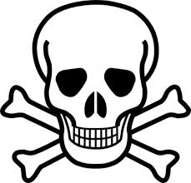

**21.**

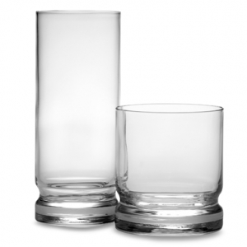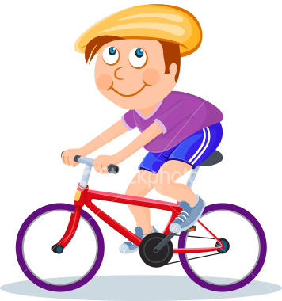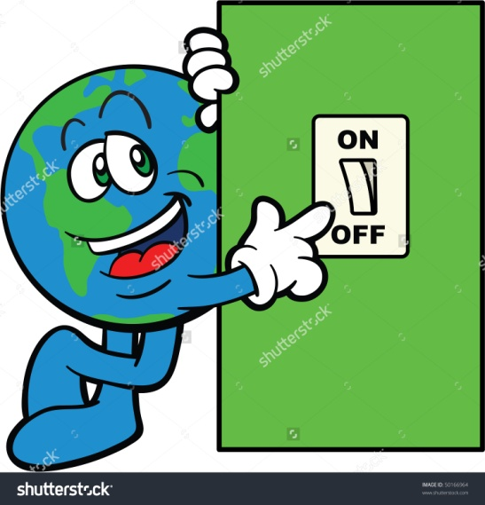

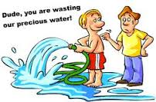

**26.**

**A) Boşlukları aşağıdaki kelimelerle doldurun.**

**forest - turn off - junk - dislike - walk - recycle - air - lake - protect - cycle - trees - waste - clean - pollute - save**

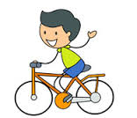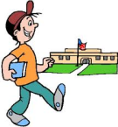**1.** We should ......................... paper, glass and plastic materials.

**2.** We must .................. or ....................... to school.

**3.** We shouldn't eat ................... food.

**4.** We must ....................... the world.

**5.** We must .............................. the TV and lights when we don't use.

**6.** Don't throw ................................ around.

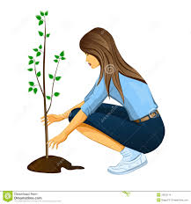**7.** Don't ..................... water. Turn off the tap.

**8.** We should plant a lot of ....................

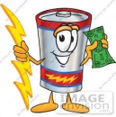**9.** I never drink cola. I ......................... it.

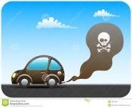**10.** Unplug the TV and ............... energy.

**11.** Cars, factories and trains cause .................... pollution.

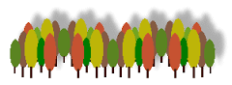**12.** Keep your classroom ...........................

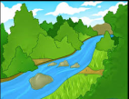**13.** There are a lot of trees in a ...............................

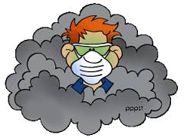**14.** I swam in the ......................... yesterday.

**15.** Don't ................ the environment, please. Use rubbish bin.

**B)Kelimelerle Türkçelerini eşleştirin. C)Test sorularını çözün.**

1.Glass:

a.kağıt b.cam c.plastic d.demir

2.Paper:

a.kağıt b.cam c.plastic d.demir

3.Tree:

a.orman b.göl c.ağaç d.nehir

4.River:

a.orman b.göl c.ağaç d.nehir

5.Environment:

a.orman b.dünya c.kirlilik d.çevre

6.Dislike:

a.hoşlanmak b.sevmek

c.nefret etmek d.hoşlanmamak

7.A lot of:

a.birkaç tane b.biraz

c.bir sürü d.birazcık

1.Pollute___

2.Air pollution___

3.Save___

4.Waste___

5.Rubbish___

6.Plant trees___

7.Cut trees___

8.Make fire___

9.Keep clean___

10.Factory___

11.Turn on___

12.Turn off___

13.Cycle___

14.Bottle___

15.Public transportation ___

A. İsraf etmek

B. Ateş yakmak

C.Ağaç dikmek

D. Açmak

E. Kirletmek

F. Fabrika

G. Şişe

H. Çöp

I. Toplu taşımacılık

J. Bisiklet sürmek

K. Ağaç kesmek

L.Temiz tutmak

M. Tasarruf etmek

N. Kapatmak

S. Hava kirliliği