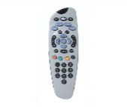1. It is a …………..

A) tv guide B) couch potato

c) remote control D) channel

2. He is a______

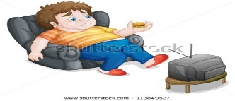

3. I prefer _______ to music to sleeping.

1. to listen
2. listen
3. listening
4. listens

4.Children like watching ____

1. cartoons
2. documentary
3. news
4. soup operas

5.I prefer watching reality shows ______ they are interesting.

1. But
2. Because
3. To
4. For

6. Aslı prefers watching sit-coms. She thinks they are ______

1. Nonsense c) boring
2. Amusing d) ridiculous

7. We don’t like the news.

It is…….

1. interesting c) funny
2. amusing d) boring

8. Horror films are………..

1. nonsense c) boring
2. terrifying d)funny

9. How often do you go to İzmir?

I ………… go to İzmir. I like İzmir.

1. Often
2. Never
3. Everyday
4. Twice a day

10. How often do you have bath?

I have a bath …………

1. often
2. usually
3. never
4. twice a week

11. My father can’t ____football. He hates watching matches.

1. stand c) like
2. do d) good

12. Kerem is good ____ dancing.

1. in c) for
2. by d) at

13. What is your ____ TV programme?

a) remote control b) prefer

c) favourite d) different

14. Find the odd one

1. soap opera
2. cartoons
3. horror films
4. coach potato

15. Find the odd one

1. reptile
2. mammal
3. rhinoceros
4. birds

16.Birds ………… 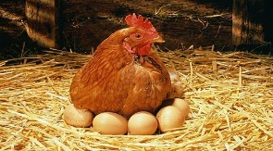

1. give birth
2. lay eggs
3. have horns
4. have trunks

17. Snakes are ………..

1. reptiles
2. mammal
3. insects
4. birds

18. Blue whales live in the …..

1. deserts
2. forests
3. jungles
4. seas and oceans

19. Some animals are endangered because of…………….

a) over hunting

b) cold weather

c) wars

d) hot weather

20. Dinasours are _____ animals.

a) endangered

b) domesticated

c) small

d) extinct

21. Dolphins have …… but they don’t have……..

a)fins / feathers

b) fur / beaks

c) scales / fins

d) paws / horns

22. on land in water

a) lion blue whale

b) zebra sharks

c) tigers sea turtles

d) bears eagles

23. Lions have …………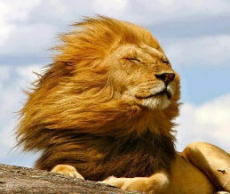

a) mane b) horns

c) long neck d) feather

24. Where do the giraffes live?

……………….. in Africa.

1. They eat
2. They live
3. They weigh
4. They have

25. ………………………………….?

They are 4 metres tall.

1. Where do they live
2. What do they eat
3. What colour are they
4. How tall are they

26.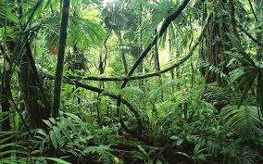 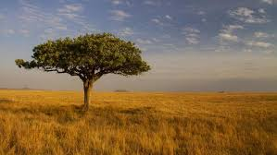

1. Habitat
2. Prey
3. Special organs
4. Weight

27. People should ……….

1. Hunt animals
2. Pollute the air
3. Use chemicals
4. Save the animals

28. A zebra’s habitat is …..

1. Africa
2. Europe
3. North Pole
4. Indian Ocean

29. Lions and tigers are wild animals. They …… other animals.

1. Watch c) feed
2. Cut d) hunt

30. Elephants have ………

a) beaks b) scales

c) trunks d) paws

31. find the odd one

a) giraffe c) fox

b) lion d) crocodile

32. find the odd one

a) ivory c) desert

b) forest d) ocean

33. I live in Africa. I am very tall. I eat leaves. I am a……

a) zebra c) bear

b) tiger d) giraffe

34. I am a reptile. I live both in water and on land. I am very dangerous. I eat other animals.

a) shark c) crocodile

b) tiger d) wolf

35. A panda eats………

a) meat c) insects

b) bamboo leaves d) wolf

1. **MCj03982830000%5b1%5d**

**He prefers_____basketball to_____football**

a)Playing—playing b) to play----to play

c) play---play d) played----played

37. **_______ TV program do you prefer?**

**- I prefer watching documentary.**

A) What kind of B) When

C) How D) What

38. **An elephant has got………….**

a) Trunk b) fin c) wings d) beak

39. **. I prefer watching documentaries because they are…………………..**

a) entertaining b) nonsense c) educational d) violent

40. **I don’t prefer watching TV because ……** a) It is entertaining b) it is educational

c) it is funny. d) it is boring.

41. **Mike prefers cartoons …………. they are funny.**

a) but b) because

c) to d) and

42. **I prefer watching news because**

**they are more ……………… than series.**

1. interesting C) boring
2. nonsense D) funny

43. **Some wild animals are ……………… because they lose their habitats because of deforestation.**

a) species c) habitat b) endangered d) domestic

44. 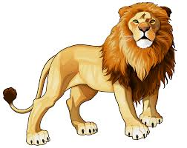

**Lions are …………………**

1. mammals c) domestic
2. reptiles d) extinct

45. **How often does your grandfather watch TV?**

**He______ watches TV. He doesn’t like it.**

1. **Always c) never**
2. **Twice a day d) everyday**

46. **.**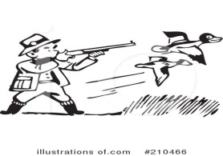

1. **we shouldn't hunt animals**
2. **we shouldn’t cut the trees**
3. **We should stop global warming.**
4. **We should stop pollution**