**2017-2018 ACADEMIC YEAR BEYAZSEHIR IMKB PRIMARY SCHOOL**

**2nd TERM 4th GRADE 1st ENGLISH EXAM**

**Name-Surname:................................. ..........Class-Number:.............**

A) **Aşagidaki resimlerin altına doğru kelimeleri yazınız. (10x2=20 pts)**

seed - doing experiment - soil - make hole - sunny place – googles – plant –fold - pot - water

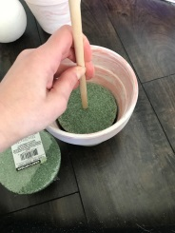 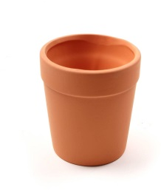 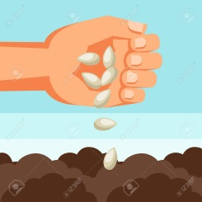 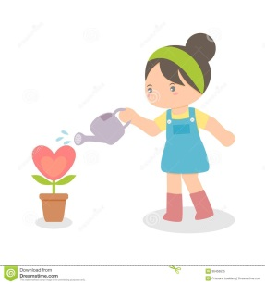 

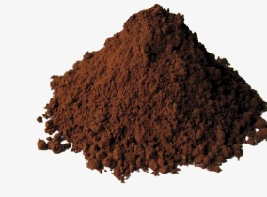  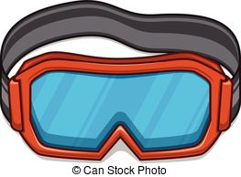 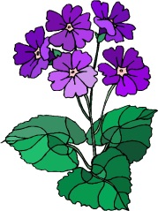

...................................... ................................ ................................. ...................................... .....................................

**B) Aşagidaki boşlukları uygun yer sözcükleriyle tamamlayınız. (6x2=12 pts)**

**\*next to *on * in front of * behind * in * between**

 The mouse is .................. the **box.** 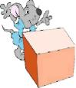 The mouse is ................... **the box.**

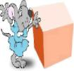 The mouse is  **............. the box.** **The mouse is ...............** the box

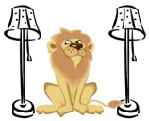 The lion is ................. two lamps. 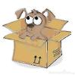The dog ıs .....................the box.

**C) Aşağıdaki boşluklara uygun kelimeleri yazın. (1x10=10)**

get dressed -watch TV - wake up - do homework - have dinner- brush teeth - have a shower –

go shopping --- wash face --- go to school

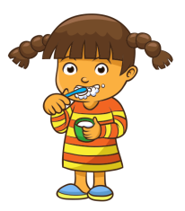    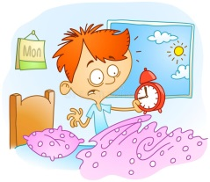

...................... .............................. ........................ .................................. ......................................  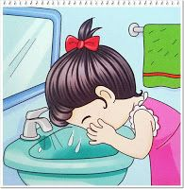 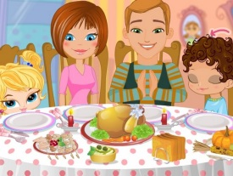 

..................... ............................... ..................... ........................... .........................

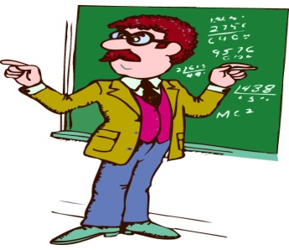 **D) Soruları örneğe bakarak cevaplandırınız(3*15=45pts)**

|  |  |  |
| --- | --- | --- |
| Who is he/she?  He ıs a teacher | Where does he/she work?  He works at a school | What does he/she like?  He likes teaching |

|  |  |  |
| --- | --- | --- |
| Who is he/she? | Where does he/she work? | What does he/she like? |





|  |  |  |
| --- | --- | --- |
| Who is he/she? | Where does he/she work? | What does he/she like? |

|  |  |  |
| --- | --- | --- |
| Who is he/she? | Where does he/she work? | What does he/she like? |



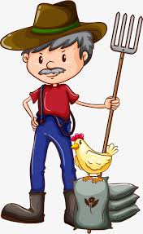

|  |  |  |
| --- | --- | --- |
| Who is he/she? | Where does he/she work? | What does he/she like? |



|  |  |  |
| --- | --- | --- |
| Who is he/she? | Where does he/she work? | What does he/she like? |

E) **Aşağıda verilen soruları ve cevapları birbiriyle eşleştiriniz. (2*5=10p )**

a ) What is the time? ___ It is twelve o’clock.

b) What is this in English? ___ It is in the container.

c) Where is the test tube? ___ It is “microscope”.

d) What is your job? ___ She is a dancer.

e) What is her job? ___ I am a dentist.

F) Boslukları verılen kelımelerle doldurunuz(1*3=3 p)

IN ON AT

1. I have lunch ..................12;00 o’clock
2. I go shopping .....................Saturdays.
3. I wash my face ...................the mornıng.

**Bonus:Gunlerı yazınız:**

**ALEV ARSLAN**

**Teacher of ENGLISH**

**The mouse**.