**[](http://www.google.com.tr/imgres?imgurl=http://12june.org/site/wp-content/uploads/2010/07/giantletter.gif&imgrefurl=http://org2.democracyinaction.org/o/6160/p/dia/action/public/index.sjs?action_KEY=3570&usg=__GoS-agW3ahctatYV49DyMneRMn0=&h=291&w=300&sz=27&hl=tr&start=48&zoom=1&itbs=1&tbnid=Qfp8lV2EgJ3hdM:&tbnh=113&tbnw=116&prev=/images?q=blank+letter+page&start=40&hl=tr&sa=N&gbv=2&ndsp=20&tbs=isch:)**

**Score:**

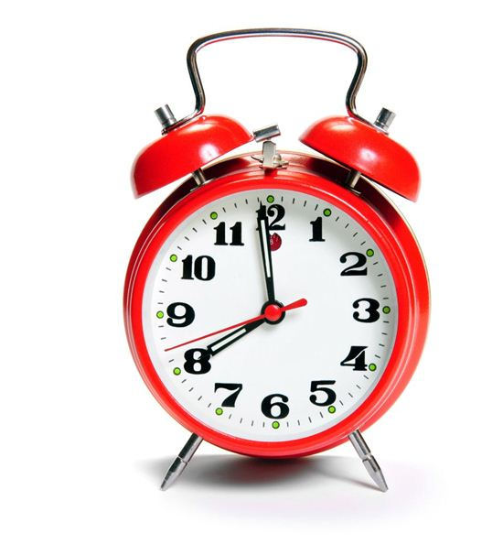**Duration:40 minutes**

**.................... SECONDARY SCHOOL 7th GRADE ENGLISH LESSON 2nd TERM 1st EXAM**

**NAME: SURNAME: NUMBER: CLASS: DATE: 16/03/2017**

**A) Doğru seçeneği işaretleyin**

**( 21x2=42 puan )**

**1) Aysel : I prefer watching quiz shows ______ news because I think quiz shows are more exciting.**

A) and B) but C) or D) to

**2)**

**Yukarıdaki resimlere göre hangi cümle doğrudur?**

A) I prefer reality shows

B) I don’t like sports programmes

C) I prefer documentaries

D) I prefer watching sports programmes

**3) We had sleepover party ___________.**



A) in the morning

B) at night

C) in the afternoon

D) all day

**4) A ______________ guides the technical crew and actors, directs the making of a film.**

A) director B) camera operator

C) costume designer D) set decorator

**5) Resimdeki çocuklar hangi partide olabilirler?**

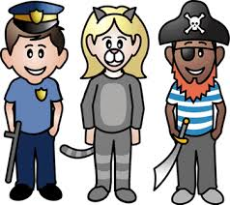

A) birthday party

B) fancy dress party

C) dinner party

D) pyjamas party

**6) “wedding party” aşağıdaki resimlerin hangisinde**

**gösterilmiştir?**

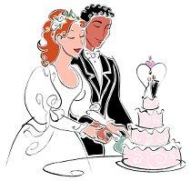

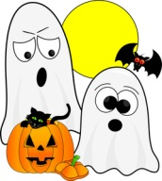A) B) C) D)

**7) I need __________________for Halloween party.**

A) party hats and candles

B) a big cake

C) a pirate hat

D) candies and pumpkins

**8) Aşağıdaki yapılacaklar listesinde boş bırakılan yerlere sırasıyla hangi kelimeler gelmelidir?**

TO DO LIST

*………. the guest list

*arrange music

*………… the place

A) prepare / decorate

B) buy / organize

C) organize / buy

D) prepare / buy

**9) If you want to organize a birthday party, you need _________________**

**Cümlenin sonundaki boşluğa hangisi gelemez?**

A) candles B) invitation cards

C) party hats D) horror movies

**10) If you are going to a friend’s birthday party, _____ you should buy a present for him/her.**

A) first B) would like C) finally D) then

**11) Hasan : I think, We should give the party at**

**home.**

**Mehmet : No, ___________________**

A) That’s a great idea

B) OK. Let’s

C) That’s not a good idea

D) I agree with you

**12) Selen : _________we invite Gizem to the party?**

**Melis : OK.**

A) Why don’t B) Let’s

D) What about D) We should

**13) Can : I am bored. Let’s go to the cinema**

**Ali : ___________ I must do homework.**

A) Great idea

B) Ok. Let’s go

C) Yes.

D) No, Let’s not

**14) Serdar : Do you want ice cream or lemonade?**

**Ertuğrul : ________________________**

**Serdar : Do you want ice cream or lemonade?**

**Konuşmadaki boşluğa aşağıdakilerden hangisi gelemez?**

A) Sorry, I didn’t understand.

B) Can you repeat it please?

C) I prefer ice cream.

D) what was that again?

**15) Birol : Would you like some water?**

**Şeyma : Yes, _______________**

A) just a little B) just a few B) one or two D) many

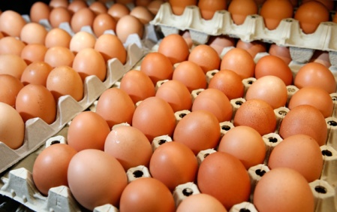**16) ______________ eggs.**

A) A few

B) a little

C) some

D) a lot of

**17-18-19-20 ve 21. soruları aşağıdaki davetiyeye gör cevaplayın**

New Message

To

Subject

Hi, Rebecca,

We’re having a surprise birthday party for Alan on 22nd June at Adrian’s garden (22 Victoria Road, NW6). The party is from 3 to 6 in the afternoon. Would you like to attend the party? If you accept the invitation, please reply my e-mail. We collect €5 for the expenses and the birthday present.

Martha

PC: Could you help us to wrap the presents?

**17) This is a ______________ party invitation card.**

A) wedding B) fancy dress C) dinner D) birthday

**18) Who is sender?**

A) Tom B) Rebecca C) Martha D) Alan

**19) Where is the party?**

A) Adrian’s home B) Adrian’s garden

C) Victoria Cafe D) Sun Cafe

**20) Which one is false about the party?**

A) The party will be at 22 Victoria Road,NW6

B) The party will start at 3 p.m.

C) The party will finish at 6 p.m.

D) Guests will give no money for the gift.

**21) When is the party?**

A) Next week B) 22nd June C) 15:00 D) Victoria Road

**B) Metni okuyarak alışveriş listesini madde madde tamamlayın (4x4=16 puan)**

Hey Mark

Shopping List

1. ________________

2.________________

3.________________

4.________________

I want to organize a party for my

parents’ wedding anniversary.

But I must go and deliver the

invitation cards. Can you help me

with the shopping?

First, to decorate the home

buy a lot of balloons then go to

the music store and buy a few

music Cds. Of course we need

a big cake. Finally don’t forget

to buy some flowers .

Thank you.

**C) Aşağıdaki cümleleri uygun seçenekler ile rakamların altına harfleri yazarak tamamlayınız. ( 6x3=18puan )**

|  |  |  |  |  |  |
| --- | --- | --- | --- | --- | --- |
| **1.** If you find a four leaved clover, …  **2.** If you want your house to attract luck, …  **3.** You will have seven years bad luck, …  **4.** You will be unlucky, …  **5.** You will avoid bad luck, …  **6.** You will be unlucky, … | | | **a.** … if you walk under a ladder.  **b.** … you will be lucky.  **c.** … if you touch wood.  **d.** … if you open an umbrella indoors.  **e.** … if you break a mirror.  **f.** … put a horse shoe right up over the door. | | |
| **1** | **2** | **3** | **4** | **5** | **6** |
|  |  |  |  |  |  |

**D) Kutunun içindeki ifadelerin sadece sayılarını uygun resimlerin altına yazarak eşleştirin.**

**( 8x3=24 puan )**

**1.** palm reading **5.** four leaf clover

**2.** walking under a ladder **6.** black cat

**3.** horse shoe **7.** coffee reading

**4.** opening an umbrella indoors **8.** breaking a mirror

   