Soru 1
Aşağıdaki resmi anlatan kelime hangi seçenekte doğru verilmiştir?
A) snowy
B) rainy
C) foggy
D) cloudy

Soru 2
We can’t go on a picnic because it is .................. .
A) stormy
B) hot
C) sunny
D) nice

Soru 3
What ........... the weather like in the evening?
A) is B) are C) does D) do

Soru 4
Hansel : ..................................
Gretel : It’s 21 degrees Celcius.
Yukarıdaki diyaloğu tamamlayan soru hangi seçenekte verilmiştir?
A) Is it snowy today?
B) What is the weather like?
C) How is the weather in the morning?
D) What is the temperature?

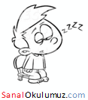
Soru 5
"How does he feel?"
Yukarıdaki soruyu resme göre cevaplayınız.
A) happy
B) sleepy
C) scared
D) upset

Soru 6
Tom ............... scared in stormy weather.
A) like B) don’t like C) feeling D) feels

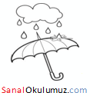
Soru 7
Take your umbrella. It’s ................ today.
A) rainy
B) sunny
C) foggy
D) hot

Soru 8
It is ......................... .We can make a snowman.
A) snowy B) snow C) rainy D) rain

Soru 9
"What is the weather like in summer?"
Aşağıdakilerden hangisi yukarıdaki sorunun cevabı olamaz?
A) hot B) warm C) sunny D) snowy

Soru 10
Aşağıdaki eşleştirmelerden hangisi yanlıştır?
A) winter – hot
B) spring – warm
C) autumn – rainy
D) summer – sunny

Soru 11
Hangisi farklıdır?
A) scared B) upset C) sad D) happy

Soru 12
Selin : ............. do you feel today?
Ece : I feel fine.
A) Where B) Why C) How D) When
Soru 13
Andy : Does the weather affect your emotions?
Clara : Yes, it does. I don’t like stormy weather. I feel scared when there is lightning. But I feel happy and energetic on sunny days. I want to go out and meet my friends.
Yukarıdaki diyaloğa göre aşağıdakilerden hangisi doğrudur?
A) Clara likes stormy weather.
B) Clara feels happy and energetic on stormy days.
C) Clara feels scared on sunny days.
D) Clara wants to go out on sunny days.

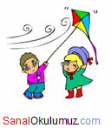
Soru 14
It is ...................... today. Let’s fly a kite.
A) snowy
B) stormy
C) windy
D) hot

Soru 15
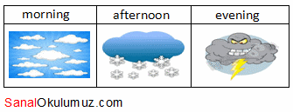Tabloya göre aşağıdakilerden hangisi doğrudur?
A) It’s sunny in the morning.
B) It’s snowy in the afternoon.
C) It’s rainy in the afternoon.
D) It’s hot in the evening.

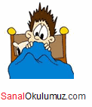
Soru 16
Mum : How do you feel?
Son : I feel.................. .
Yukarıdaki diyaloğu resme göre cevaplayınız.
A) happy
B) upset
C) energetic
D) scared
Soru 17
“What is the weather like in winter?”
Aşağıdakilerden hangisi yukarıdaki sorunun cevabı olamaz?
A) snowy B) stormy C) cold D) hot

Soru 18
Hangisi farklıdır?
A) winter B) summer C) spring D) foggy

Soru 19
I like summer because it is usually ........................... in summer.
A) rainy and cold
B) snowy and freezing
C) cold and windy
D) hot and sunny

Soru 20
It is always warm or hot in Cairo. There are only two seasons. Summer is from May to October and it is always very hot – sometimes 35 degrees Celcius or 40 degrees Celcius. Winter is from November to April and in the day time it is nice and warm – usually between 18 degrees Celcius and 24 degrees Celcius. But it is sometimes very cold at night.
Yukarıdaki paragrafa göre aşağıdakilerden hangisi yanlıştır?
A) It is very hot in May in Cairo.
B) Winter is from November to April.
C) There are four seasons in Cairo.
D) It is between18 degrees Celcius and 24 degrees Celcius in Cairo.
Name:
Surname:
Class:
Number:

