- Write the Turkish meanings of the weather conditions. (1x15=15pts)
Sunny: snowy: windy: rainy:
Stormy: foggy: cloudy: hot:
Cold: warm: freezing: cool:
Chilly: icy: partly cloudy:
- Write the Turkish meanings of emotions. (1x15=15pts)
Moody: happy: sleepy: excited:
Upset: anxious: scared: bored:
Lonely: shocked: worried: tired:
Angry: relaxed: energetic:
- Answer the questions according to the pictures. (5x4=20pts)

- What is the weather like in Sinop?  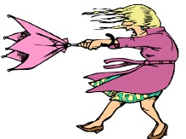 | 1-………………………………………………
- What is the weather like in Kars? | 2-…………………………………………….
- What is the weather like in Ankara? | 3-……………………………………………
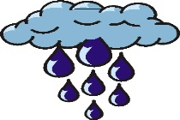  - What is the weather like in Rize? | 4-……………………………………………..
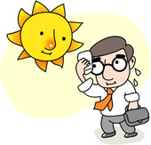  - What is the weather like in Antalya? | 5-…………………………………………….
- Make sentences about the temperatures. (4x4=16pts)

- A: What is the temperature? (15’C) 2- A: What is the temperature? (20’C)
B: ………………………………………………….. B:……………………………………………………….

- A: What is the temperature? (-12’C) 4- A: What is the temperature? (-16’C)
B: …………………………………………………… B:………………………………………………………..
- Match the answers with the questions. (8x2=16pts)
1-What is the weather like today? |  | a- It is rainy in the morning.
2-What is the temperature? |  | b- It is freezing in the evening.
3-What is the weather like in the morning? |  | c- It is cloudy today.
4-How do you feel in sunny weather? |  | d- I feel happy in sunny weather.
5-What is the weather like in Samsun? |  | e- It is six degrees Celcius.
6-What is the weather like in the evening? |  | f- I feel lonely in rainy weather.
7-How do you feel in rainy weather? |  | g- It is hot in Antalya.
8-What is the weather like in Antalya? |  | h- It is warm in Samsun.

1-………. | 2-………. | 3-……… | 4-……….. | 5-………. | 6-………. | 7-……….. | 8-…………

- Choose the correct option according to the map. (6x3=18pts)
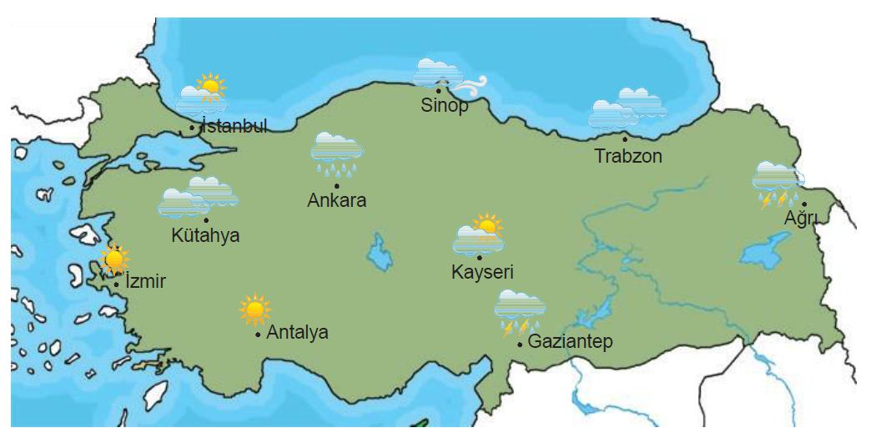
1-What is the weather like in İstanbul?  a)It is rainy. b) It is snowy.  c)It is partly cloudy. d)It is foggy. | 4-What is the weather like in Ankara?  a)It is hot. b)It is freezing.  c)It is rainy. d)It is snowy.
2-Haritaya göre hangi cümle doğrudur?  a)The weather is cloudy in Antalya.  b)The weather is windy in Kütahya.  c)The weather is rainy in İzmir.  d)The weather is stormy in Gaziantep. | 5-Haritaya göre hangi cümle yanlıştır?  a)The weather is partly cloudy in Kayseri.  b)The weather is cloudy in Kütahya.  c)The weather is snowy in Ağrı.  d)The weather is sunny in İzmir.
3-What is the weather like in Sinop?  a)It is windy. b)It is rainy.  c)It is sunny. d)It is cold. | 6- What is the weather like in Antalya?  a)It is sunny. b)It is cloudy.  c)It is windy. d)It is freezing.

