FARM ACTIVITIES
A) feed the chicks B) collect the apples C) milk the cow D) work in the garden E)water the flowers
F) collect the eggs G) plant the vegetables H) feed the goats I) feed the goose J) give seed to chicken
K) take the dog for a walk L) feed the family pet
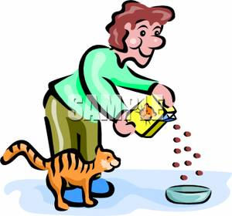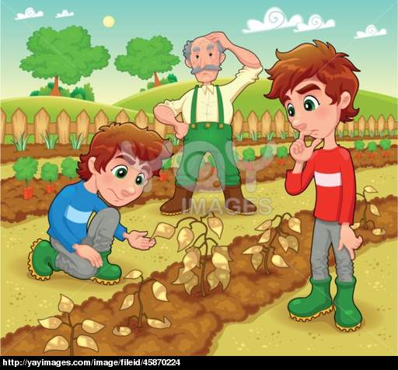
1)………………………….. 2) ……………………………….. 3) …………………………………..

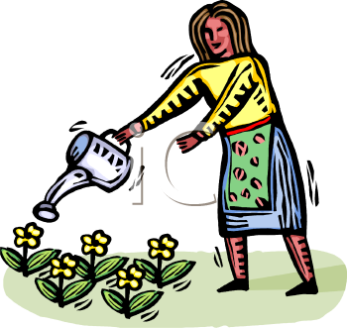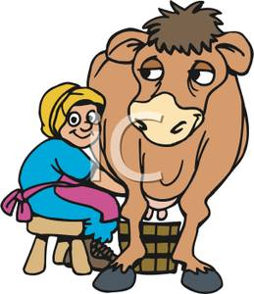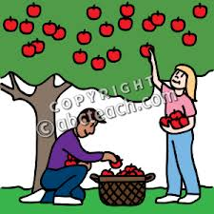
4) …………………………… 5) ………………………………….. 6) …………………………………….

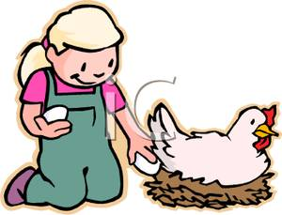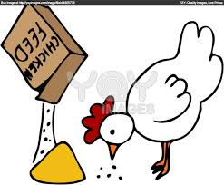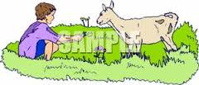
7) ……………………………. 8) …………………………………. 9) ……………………………………..

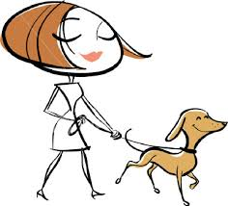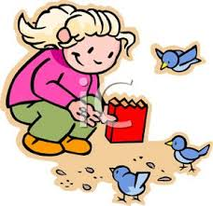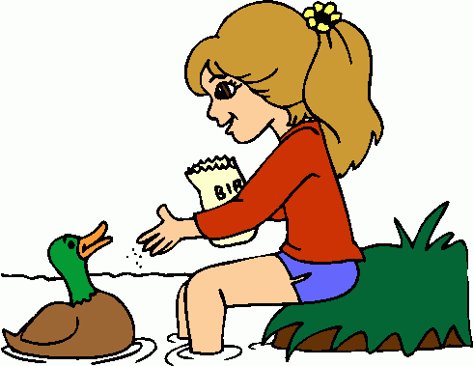
10) …………………………… 11) …………………………………. 12) ………………………………….

