# 6 number clipart ile ilgili görsel sonucuRainbow Baby Owl Cartoon Stock Photo - 176138382017-2018 Education Year Nadir Tolun Secondary School 6th Grades 2nd Term 2nd Exam of Elective English

**MARK**

**Name-Surname: ……………..………………………………………………..…………………………………………………….**

**Class: ………………………………………………… Number:……………………..…………………….……………….…**

**A-Choose the correct one.(10x4p=40p)**

**1**. **Cümleyi resme uygun şekilde tamamlayınız.**

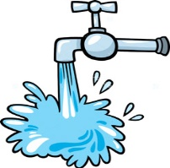

You shouldn’t ……………………………..

**A)** save water **B)** turn off the tap

**C)** pollute water **D)** waste water

**2. Altı çizili olan *yılın* doğru şekilde gösterildiği seçeneği işaretleyiniz.**

*Gülten Dayıoğlu is a famous writer. She wrote*

*her first novel Fadiş in* ***nineteen seventy-one.***

**A)** 1917 **B)** 1977 **C)** 1901 **D)** 1971

**3. Aşağıdaki paragrafta hangi sorunun cevabı yoktur?**

My father is an architect. He became an architect in 1990. He can draw plans for bridges and houses.

He can design buildings. He loves his job.

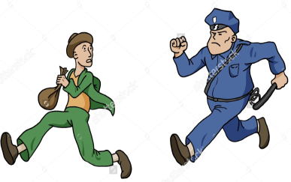 **A)** When did he become an architect?  
 **B)** Who is an architect?  
 **C)** What can an architect do?  
 **D)** What’s his favourite bridge?

**4. A: What is the police doing now?**

**B: …………………………………**

**A)** He is questioning the criminal.  
 **B)** He is chasing the thief.  
 **C)** He is running away.  
 **D)** He is taking fingerprints.

**5. Cümleyi resme uygun şekilde tamamlayınız.**

The policeman is taking the burglar’s ………... samples.

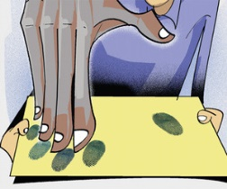

**A)** security **B)** footprint  
**C)** fingerprint **D)** steal

**6. Aşağıdaki ifadelerden hangisi yanlış yerdedir?**

|  |  |
| --- | --- |
| We had better | We had better not |
| -save the animals  -cut down trees  -unplug the TV | -use chemicals  -waste energy  -leave the TV on |

**A)** unplug the TV **B)** waste energy  
**C)** cut down trees **D)** use chemicals

**7. Aşağıdakilerden hangisi yanlıştır?**

**A) 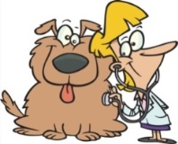 B)** 

**Vet Waitress**

**C) 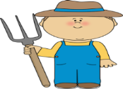 D) **

**Farmer Pilot**

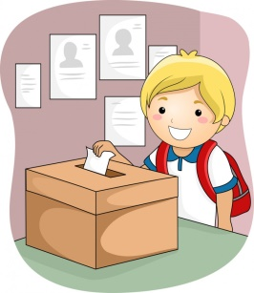

**8. Görsele göre Emirhan ne yapıyor?**

|  |
| --- |
| **A)** Emirhan is making a speech. |
| **B)** Emirhan is finding a slogan. |
| **C)** Emirhan is voting. |
| **D)** Emirhan is putting up posters. |

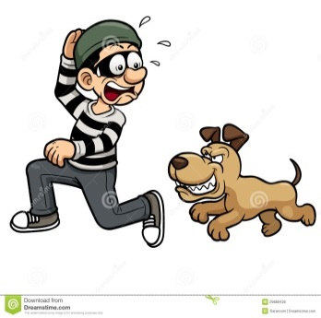**9. Cümleyi resme uygun şekilde tamamlayınız.**

The dog is …………. the thief.

**A)** under **B)** in

**C)** between **D)** behind

**10. Aşağıdaki cümlelerden hangisi çevre açısından doğru bir bilgidir?**

**A)** We should throw rubbish on the ground.  
 **B)** We shouldn’t turn off the lights.  
 **C)** We should recycle paper, glass and plastics.  
 **D)** We shouldn’t protect the environment.

**B- Complete the sentences with “should / shouldn’t”. (5x4p=20p )**

**1.** We ***………………………………………………………………………*** pollute the air.

**2.** We **……………………………………………………………………….** plant more trees.

**3.** We ***…………………………………………………………………*** save animals in danger.

**4.** We ***…………………………………………………...……………*** leave the water running.

**5.** We ***…………………………………….…………………………………*** use recycle bins.

**C- Match the numbers. (5x4p=20p)**

**a)** 48.271 **1)** six hundred twelve thousand, nine hundred thirty five

**b)** 612.935 **2)** eight million

**c)** 5.432 **3)** nine hundred and eighty seven

**d)** 8.000.000 **4)** forty eight thousand, two hundred and seventy one

**e)** 987 **5)** five thousand, four hundred and thirty two

|  |  |  |  |  |
| --- | --- | --- | --- | --- |
| **a)** | **b)** | **c)** | **d)** | **e)** |

**D- Read the text and write TRUE or FALSE. (5x4p=20p)**

This is Merve. She is 12 years old. She is a 6th grade student. She plays volleyball in the school team and also she likes tennis. She is very good at volleyball and tennis. She is responsible and respectful to everyone, so all her friends like Merve. She always helps her friends and she respects others’ rights.



|  |  |
| --- | --- |
|  |  |

1. **(………………………………..)** Merve is eleven years old.
2. **(………………………………..)** She is a helpful girl.
3. **(………………………………..)** She is a player of the school volleyball team.
4. 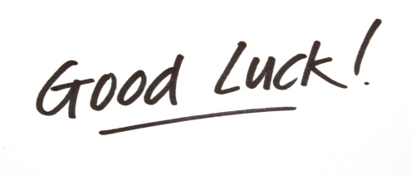**(………………………………..)** Merve can’t play tennis well.
5. **(………………………………..)** She is a respectful girl.

**Gizem YEŞİLOĞLU**