2017-2018 EDUCATIONAL YEAR OSMAN NURİ BAKIRCI SECONDARY SCHOOL
ELECTIVE ENGLISH LESSON SECOND TERM SECOND WRITTEN EXAM FOR THE 6TH GRADES
Name - Surname: Class: Number:
READING PART
A)Read the text and write TRUE or FALSE. (5X2=10points)
Cindy: Hi. How was your holiday?
Kevin: We went to Bodrum with my family.It was very good.
Cindy: What did you do?
Kevin: I swam in the sea. I climbed to the mountains.I rode bicycle.
Cindy: Where did you stay ?
Kevin: We stayed in a hotel.
Cindy: How was it?
Kevin: It was amazing. What did you do on your holiday?
Cindy: We went to İzmir. I swam in the sea. I read book and I played volleyball with my friends.
Kevin: Amazing. See you later. Good bye!
Cindy: Good bye!
1. Kevin went to Bodrum with his family ……….
2. He didn’t swim in the sea ………..
3. Kevin and his family didn’t stay in a hotel …….
4. Cindy went to Bodrum on her holiday ……..
5. Cindy played volleyball with her friends ……..

VOCABULARY PART
B)Match the correct words with the pictures.(5x2=10points)
magnifier / painting / footprints / burglar / break into
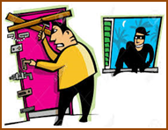 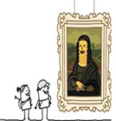
1)……….. 2)……………. 3)…………………… 4)……………… 5)………………..
C) Choose the correct option (7x2=14points)
1)I can pull out teeth. a)Dentist b) Tailor c)Teacher d) Nurse
2)I can draw plans of buildings, houses .a) Mechanic b) Dentist c) Secretary d) Architect
3)I can repair cars . a) Engineer b) Policeman c) Mechanic d) Lawyer
4)I can examine ill people. a) Doctor b) Nurse c) Vet d) Artist
5)I can cut and dye hair . a) Painter b) Hairdresser c) Cook d) Farmer
6)I can sew clothes, dress, T-shirt. a) Doctor b) Tailor c)Manager d) Nurse
7)I can fly the planes and helicopters. a) Butcher b) Pilot c) Lawyer d)Teacher
D.Match the pictures with the sentences (6x2=12points)
A) Recycle B) Plant trees C) Use public transportation D) Use bicycle for transportation
E) Don’t waste water F) Don’t cut down trees
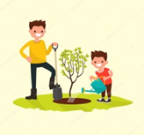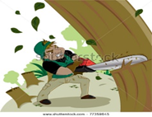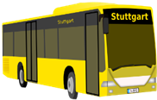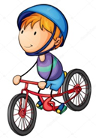
1)…………. 2)…………….. 3)………………….. 4)…………… 5)………….. 6)………………
GRAMMAR PART
E.Choose the suitable one. (5x2=10 points)
1.Hakan was / were in Antalya last summer.
2.I and my family was/ were on vacation last month.
3.My cat wasn’t / weren’t at home yesterday.
4.Amelia was/ were happy last weekend
5.Was/ Were they busy on Friday evening?
F. ) Fill in the blanks with “should” & “shouldn’t”.(10x1=10points)
1)We ________________ recycle paper, glass, plastic and cans.
2)He ________________ waste the water..
3)You ________________ buy plastic bags.
4)We ________________ turn off the electricity.
5)They ________________ save animal in danger.
6)We ________________ turn off the lights when I leave the room.
7)I ________________ leave the water running when I brush my teeth.
8)We ________________ walk or ride bike to school.
9)You ________________ drop litter.
10)We ________________ stop the pollution.
G)Match the sentences with the pictures.(5x2=10points)
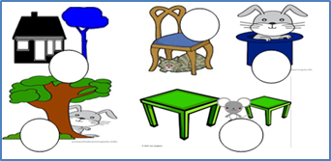
1)The rabbit is in the hat.
2) The cat is under the chair.
3) The tree is near the house.
4) The mouse is between the tables.
5) The rabbit is behind the tree.
H)Circle the correct option.(2x4=8points)
1. My father and I were on ……………… last week.
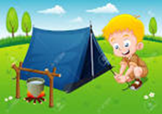 a) the seaside b)farm c)camping holiday d)sunbathing

2. I’m a ……………and I can ………….. delicious meals.
) a) chef / cook b)architect/draw c)mechanic/repair d)secretary/write

WRITING PART
I)Write the sentences with ‘Let’s’ , ‘Why don’t we…?’ and ‘How about…?’(4x4=16points)
1)going to the park ? ………………………………………………………
2)swim . ………………………………………………………
3)read book ? ………………………………………………………
4)walk to school. ……………………………………………………….

GOOD LUCK
ENGLISH TEACHER
ÇİLEM HAŞİMOĞLU

