**6TH GRADE QUIZ 2**

**Name: POINT:  
Surname:**

**A.KELİMELERİ, RESİMLERİN ALTINA DOĞRU BİR ŞEKLİDE YAZIN. (5x2 = 10 pts)**

sausages croissant cucumber muffin cheese

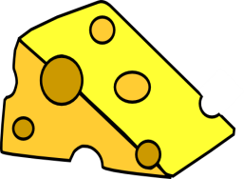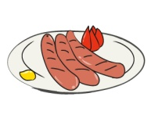

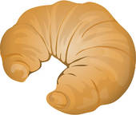

_____________ **___________ _____________ ____________ _____________**

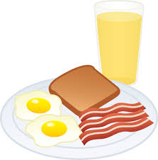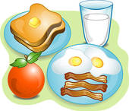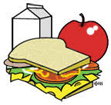**B. KONUŞMA BALONLARIYLA RESİMLERİ EŞLEŞTİRİNİZ. ( 5X5 =25 pts)**



(_____________) (_______________) (_______________) (______________) (_____________)



Hi! My name is **Onur**. I like eating eggs, sausages and toast at breakfast. My favourite drink is orange juice.



Hello! I’m **Yeşim**. My favourite food is pancake at breakfast and I like tea. I don’t drink milk or orange juice at breakfast.

Hello! I’m **Sedat.** I always eat toast, eggs, sausages and an apple at breakfast. I drink a glass of milk every morning.



Hello! My name is **Anıl.** I love eating cereal with milk at breakfast. I don’t like cheese, olives or tomatoes at breakfast.



Hi! I’m **Emel**. I eat an apple and toast at breakfast. I don’t like tea or coffee. I like milk.

**D) DOĞRU KELİMEYİ YUVARLAK İÇİNE ALIN. ( 10x4 =40 pts. )**

6. ) He **have / has** breakfast at 08.00.

7.) My cat **drink / drinks** milk everyday.

8.) We **don’t / doesn’t**  have lunch at 12.30

9.) **Do / Does** Emre play computer game?

10.) She **sleep / sleeps** early every evening.

1.) I **get up / gets up** early every morning.

2.) Meltem **watch / watches** TV every evening.

3.) They **don’t / doesn’t** do their homework.

4.) Nil and Aynur **play / plays** tennis on Sundays.

5**.) Do / Does** you have breakfast every day?

|  |  |
| --- | --- |
| **Aşağıdaki soruların doğru cevaplarını bulup işaretleyin.( 5x5 =25 pts)**   |  | | --- | | **1**.“She always has ............. at 6 o’clock in the morning.”  **Yukarıdaki cümlede boş bırakılması gereken yere aşağıdakilerden hangisi getirilmelidir?** | |
| |  |  |  |  |  |  |  |  |  |  |  |  |  |  |  |  |  |  |  |  |  |  |  |  |  |  |  |  |  |  |  |  |  |  |  |  |  |  |  |  |  |  | | --- | --- | --- | --- | --- | --- | --- | --- | --- | --- | --- | --- | --- | --- | --- | --- | --- | --- | --- | --- | --- | --- | --- | --- | --- | --- | --- | --- | --- | --- | --- | --- | --- | --- | --- | --- | --- | --- | --- | --- | --- | --- | | |  |  | | --- | --- | | |  | | --- | |  | | | |  |  |  |  | | --- | --- | --- | --- | | A)  cereal | B)  launch | C)  breakfast | D)  dinner | |   **2.**   |  |  |  |  | | --- | --- | --- | --- | | |  |  | | --- | --- | | http://cdn.okulistik.com/qimage/tr/300376/840.png | **Konuşma balonunda boş bırakılan yere aşağıdakilerden hangisi getirilmelidir?** | | | | |  | | --- | | A)  I get up at 7 o’clock in the morning. | | B)  I eat olive and bagel for breakfast. | | C)  I don’ like hamburger. It is unhealthy. | | D)  I eat breakfast at 8 o’clock.   **3.**   |  |  | | --- | --- | | |  | | --- | | A: Do you want jam for breakfast? B: No, thanks. .......................... **Yukarıdaki konuşmada boş bırakılan yere aşağıdakilerden hangisi gelmelidir?** | | | |  | | --- | | A)  I like jam very much. | | B)  It’s my favourite. | | C)  I don’t like jam. | | D)  This is a delicious breakfast. | |   **4.**   |  |  | | --- | --- | | |  | | --- | | "Croissants are unhealthy. I ............. eat croissants." **Yukarıdaki cümlede boş bırakılan yere aşağıdakilerden hangisi getirilmelidir?** | | | |  |  |  |  | | --- | --- | --- | --- | | A)  like | B)  usually | C)  always | D)  never | |   **5.**   |  |  | | --- | --- | | |  | | --- | | **http://cdn.okulistik.com/qimage/tr/300384/848.png**  Jam  **Tabloyu dikkate alarak aşağıdaki cümlelerden doğru olanı işaretleyiniz.** | | | |  | | --- | | A)  Can likes bean and honey. | | B)  Aslı doesn’t like honey. She likes bean. | | C)  Kerem likes bagel. He doesn’t like honey. | | D)  Can doesn’t like bagel. He likes jam. | | | |  | |  |  |  | |