1.-2.-3.soruları aşağıdaki konuşmaya göre cevaplayın.
Barbara: Hi, everyone ! Would you like to go to cinema tomorrow?
Kate: Sounds good. What time?
Barbara: Tomorrow at 1 p.m.
Bob: Sorry, I can’t make it. I have a basketball match then.
John: I’m coming. See you in front of the cinema.
Kate: It’s OK for me! See you:)

1) Who makes an invitation?
A)Barbara B)Kate C)Bob D)John

2) Who refuses the invitation?
A)Barbara B)Kate C)Bob D)John

3) Who accepts the invitation?
A) Bob and Barbara B) John and Kate
C) John and Bob D) Kate and Barbara
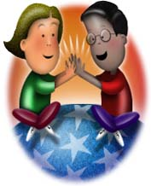
4) A) get on well
B) refuse
C) have lunch
D) sleep
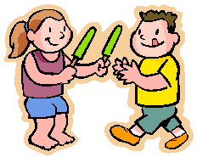
5) A) have a cold
B) share
C) watch TV
D) play computer games

6) Mary: _________ ?
Jane: By bus.
A) What time do your lesons start?
B) When does your school finish?
C) Where do you have lunch?
D) How do you g oto school?

7) British teens go to ……… on Saturday nights.
A) beach B) library C) concert D) cafe

8) A) Slumber Party
B) End-of-Term Party
C) Fancy Dress Party
D) New Years Eve Party
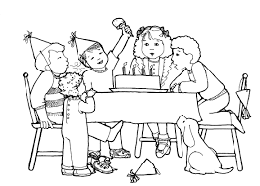
9) A) BBQ Party
B) Birthday Party
C) Hallowen Party
D) Beach Party

10) I……… TV in the evenings after dinner.
A) listen B) play C) watch D) go

11) I ……… to bed at 10 o’clock at night.
A) finish B) go C) live D) play

12) Hangi eşleştirme yanlıştır?
A) problem: difficult situation
B) holiday: vaccation
C) special: unique
D) funny: boring

13) Hangi eşleştirme doğrudur?
A)global warming: when earth becomes warmer
B) scientific test: problem
C) special: funny
D) dangerous sports : safe sports

14) A) A package of
B) A glass of
C) A piece of
D) A packet of

15) A) mix
B) dice
C) spread
D) crack

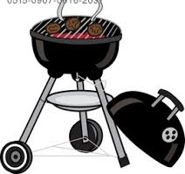
16) A) bake
B) steam
C) fry
D) grill

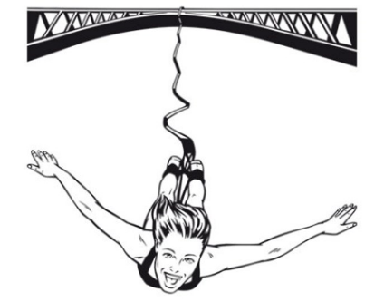

17) I love air sports. ………… is my favourite.
A) hot air balloon B) parachuting
C) swimming D) bungee-jumping
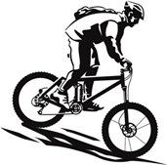 | 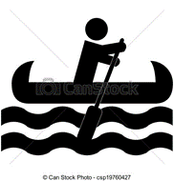

18)Yukaridaki görsele göre hangisi söylenebilir?
A) He can’t stand his bike.
B) He is crazy about water sports.
C) He prefers canoeing to mountain biking.
D) He’d rather do mountain biking.
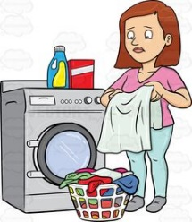

19) A) do laundry
B) dust the furniture
C) mop the floor
D) load the dishwasher

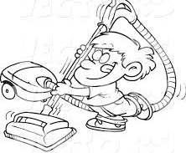
20) A) do the shopping
B) vacuuming the carpets
C) ironing
D) cooking

21)The scientists are working in the ………
A) engineer B) model
C) invent D) laboratory

22) The scientists are designing a ……… that could walk and talk.
A) robot B) build C) clever D) test

23) A) avalanche
B) flood
C) forest fire
D) drought

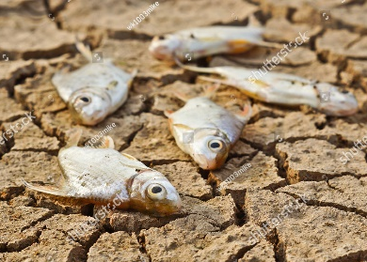
24) A) earthquake
B) landslide
C) drought
D) volcanic eruption

25)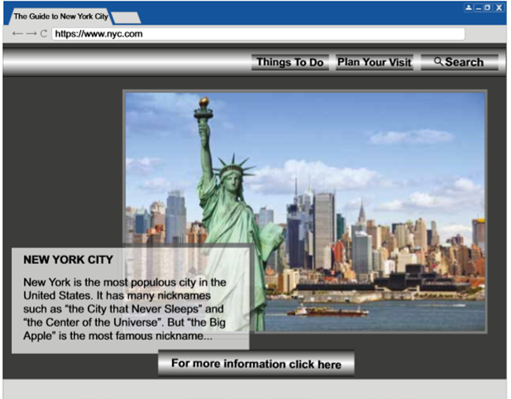

This is a text about New York City from a ………
A)newspaper B) magazine
C) book D) website

NAME & SURNAME: _____________
CLASS & NUMBER : _____________
