TELLING THE TIME, DAYS AND DATES – 6TH GRADE
Name/ Surname:
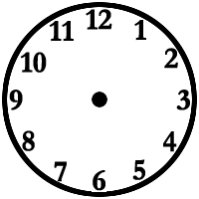
1. Draw the time.

It is five o’clock. It’s eight o’clock. It’s twelve o’clock. It’s three o’clock.
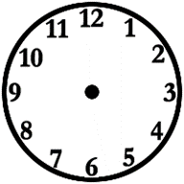

It is half past two. It’s half past nine. It’s half past eleven. It’s half past one.

It’s quarter past four. It’s quarter past six. It’s quarter past two. It’s quarter past ten.

It’s quarter to five. It’s quarter to nine. It’s quarter to four. It’s quarter to five.

It’s six o’clock. It’s half past seven. It’s quarter past one. It’s quarter to two.
2. Write the time.
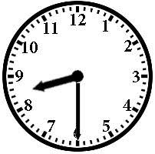
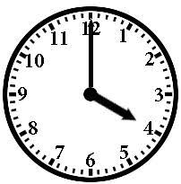
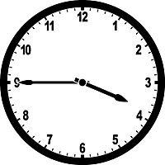
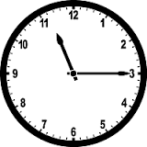
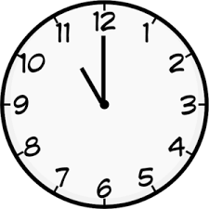
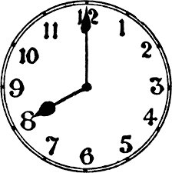
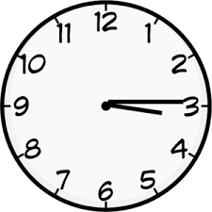
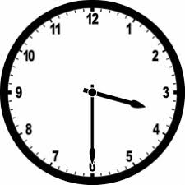
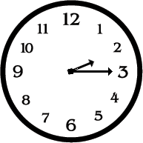

_It is quarter past three.___ _____________________ _____________________


  

