EXERCISES

UNIT 8

## A.Resimlerin İngilizce karşılığını yazınız.

[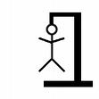](http://images.google.com.tr/imgres?imgurl=http://upload.wikimedia.org/wikipedia/commons/d/d6/Hangman-6.png&imgrefurl=http://commons.wikimedia.org/wiki/File:Hangman-6.png&usg=__xj8BtJq1LDSJGjHhB5tGdrxYkJo=&h=256&w=256&sz=3&hl=tr&start=1&sig2=WF04WUManO5i-BH3K56szQ&um=1&itbs=1&tbnid=U_0nevCOGc2cxM:&tbnh=111&tbnw=111&prev=/images?q=hangman&um=1&hl=tr&sa=N&rlz=1R2ASUS_trTR349&tbs=isch:1&ei=M5uOS4ySLty4jAejoIyXCw) [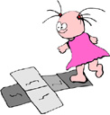](http://schools-demo.clipart.com/search/close-up?oid=3757619&q=hopscotch&s=1&a=a&k_mode=all&k_exc=&q_jpeg=1&q_gif=1&q_color=1&q_bw=1&q_eps=1&q_wmf=1&q_psd=1&q_png=1&date=&isadv=1) [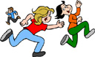](http://schools-demo.clipart.com/search/close-up?oid=3975819&q=play%20tag&s=1&a=a&k_mode=all&k_exc=&q_jpeg=1&q_gif=1&q_color=1&q_bw=1&q_eps=1&q_wmf=1&q_psd=1&q_png=1&date=&isadv=1) [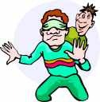](http://schools-demo.clipart.com/search/close-up?oid=2813490&q=blind%20man's%20bluff&s=1&a=a&k_mode=all&k_exc=&q_jpeg=1&q_gif=1&q_color=1&q_bw=1&q_eps=1&q_wmf=1&q_psd=1&q_png=1&date=&isadv=1) [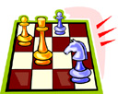](http://schools-demo.clipart.com/search/close-up?oid=3926138&q=chess&s=1&a=a&k_mode=all&k_exc=&q_jpeg=1&q_gif=1&q_color=1&q_bw=1&q_eps=1&q_wmf=1&q_psd=1&q_png=1&date=&isadv=1)

1……………… 2………………….3……………………..4………………….5…………………..

[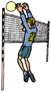](http://schools-demo.clipart.com/search/close-up?oid=3766258&q=volleyball&s=1&a=a&k_mode=all&k_exc=&q_jpeg=1&q_gif=1&q_color=1&q_bw=1&q_eps=1&q_wmf=1&q_psd=1&q_png=1&date=&isadv=1) [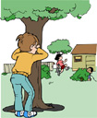](http://schools-demo.clipart.com/search/close-up?oid=3975780&q=hide%20and%20seek&s=1&a=a&k_mode=all&k_exc=&q_jpeg=1&q_gif=1&q_color=1&q_bw=1&q_eps=1&q_wmf=1&q_psd=1&q_png=1&date=&isadv=1)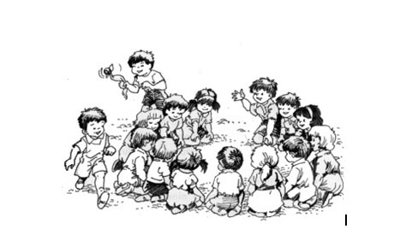

6…………………….. 7………………………… 8 ……………………………………………

[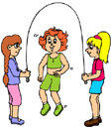](http://schools-demo.clipart.com/search/close-up?oid=3826204&q=skip%20rope&s=61&a=a&cid=&fic=0&k_mode=all&k_exc=&q_jpeg=1&q_gif=1&q_color=1&q_bw=1&q_eps=1&q_wmf=1&q_psd=1&q_png=1&date=&isadv=1) [](http://schools-demo.clipart.com/search/close-up?oid=3979509&q=puzzle&s=1&a=a&k_mode=all&k_exc=&q_jpeg=1&q_gif=1&q_color=1&q_bw=1&q_eps=1&q_wmf=1&q_psd=1&q_png=1&date=&isadv=1) [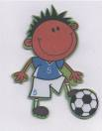](http://images.google.com.tr/imgres?imgurl=http://www.treehousecards.co.uk/users/www.treehousecards.co.uk/upload/cartoon_footie.jpg&imgrefurl=http://www.treehousecards.co.uk/index.php?f=data_handmade_greeting_cards&a=0&usg=__BtDRqRvtPX28tBoDaCS8Q9CzuQE=&h=524&w=409&sz=35&hl=tr&start=80&sig2=l09A5AFCK9cu688cR3KRcQ&um=1&itbs=1&tbnid=tvKmasrAvVBmCM:&tbnh=132&tbnw=103&prev=/images?q=football+cartoon&start=60&um=1&hl=tr&sa=N&rlz=1R2ASUS_trTR349&ndsp=20&tbs=isch:1&ei=xJ-OS8qxAouOjAfkzMCSCw) [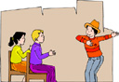](http://schools-demo.clipart.com/search/close-up?oid=3809746&q=charades&s=1&a=a&k_mode=all&k_exc=&q_jpeg=1&q_gif=1&q_color=1&q_bw=1&q_eps=1&q_wmf=1&q_psd=1&q_png=1&date=&isadv=1)[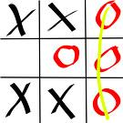](http://images.google.com.tr/imgres?imgurl=http://upload.wikimedia.org/wikipedia/commons/thumb/b/b1/Tic_tac_toe_complete.svg/600px-Tic_tac_toe_complete.svg.png&imgrefurl=http://commons.wikimedia.org/wiki/File:Tic_tac_toe_complete.svg&usg=__vTewrAgIqU9rFZMVI1kmAP7scK4=&h=600&w=600&sz=39&hl=tr&start=17&sig2=9DnlDgMN_2OxHTfUQNHVlg&um=1&itbs=1&tbnid=Qc6hleD6bDVtlM:&tbnh=135&tbnw=135&prev=/images?q=tic+tac+toe&um=1&hl=tr&sa=N&rlz=1R2ASUS_trTR349&tbs=isch:1&ei=qaSOS-LgJtLI-Qaz-OHSCQ)

9……………………….10…………………..11…………………12…………………………13…………….

C:\Users\DEMET\AppData\Local\Microsoft\Windows\Temporary Internet Files\Content.IE5\VM5IUC8S\MC900252457[1].wmf

C:\Users\DEMET\AppData\Local\Microsoft\Windows\Temporary Internet Files\Content.IE5\VM5IUC8S\MC900298637[1].wmf

14. 15.

…………………… …………………………..

B. Cümle kurunuz.

ı lıke ………………………………..

ı don’t lıke …………………………

C. 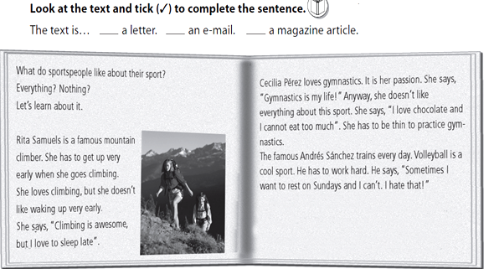

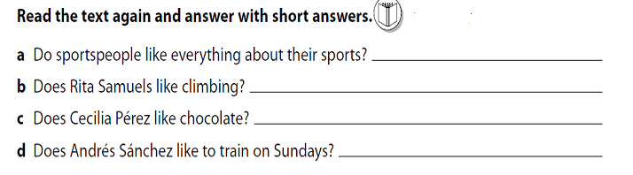

d.

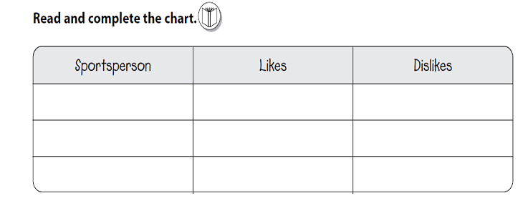

e.

f. 