5th Grade Unit 1 – Quiz
Name-Surname:
A) Complete the table. (Tablodaki eksik bilgileri tamamlayın.) 5x4p=20p
Country | Nationality | Language
1) | Spanish | Spanish
Germany | 2) | German
3) | American | English
Turkey | Turkish | 4)
Canada | 5) | English

B) Complete the sentences. (Cümlelerdeki eksik bilgileri tamamlayın.) 5x4p=20p
1) I am from China. I am …………………………………………………………………………………………..
2) I am from …………………………………………………………….. . I am Russian.
3) I am from Japan. I speak ……………………………………………………………………………………….
4) I am from Italy. I am ………………………………………………………………………………………………
5) I am from ………………………………………………………………. . I speak French.

C) Complete the dialogue. (Diyaloğu tamamlayın.) 4x4p=16p
Tim: Hi! I’m Tim. (1) ……………………………..……………….……..………. ?
My pleasure.
Carmen: Hello! My name is Carmen.
Tim: (2) …………………………………………..……………………….., Carmen?
I’m Italian.
What nationality are you?
What is your name?
Carmen: I’m Spanish. What is your nationality?
Tim: (3) .……………………………………………………………………………….. .
Carmen: Nice to meet you, Tim.
Tim: (4) ……………………………………………………………………………….. .
Gizem Yeşiloğlu
D) Write the names of the lessons. (Ders isimlerini yazın.) 6x4p=24p
Science – English – Maths – Turkish – Social Studies
Music – P.E. – Art - History

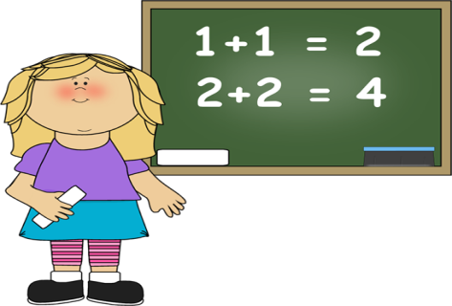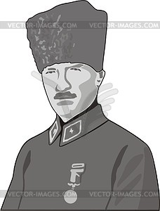
3) ……………………………
1) ……………………………
2) ……………………………

6) ……………………………
5) ……………………………
4) ……………………………

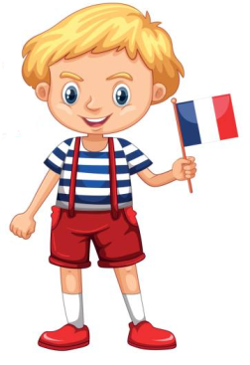
E) Look at the example and write sentences for Pierre. (Pierre için örnekteki gibi cümleler yazın.) 5x4p=20p

Example:
Name: | Emre
Age: | 10
Country: | Turkey
Nationality: | Turkish
Languages: | Turkish - English

He is Emre. He is ten years old. He is from Turkey. He is Turkish. He speaks Turkish and English.

Gizem Yeşiloğlu
Name: | Pierre
Age: | 7
Country: | France
Nationality: | French
Languages: | French - German

………………………………………………………………………………………………………………………………………………………………………………………………………………………………………………………………………………………………

