**2017-2018 ACADEMIC YEAR NADİR TOLUN SECONDARY SCHOOL**

**8TH GRADES 2ND TERM 1ST WRITTEN EXAM of ELECTIVE ENGLISH**

**NAME SURNAME:__________________________________ NUMBER:________ CLASS: 8/C MARK:_______**

**A) Match the words with the pictures. (4x4p=16p)**

**a)** sailing **b)** rock climbing **c)** parachuting **d)** bungee jumping

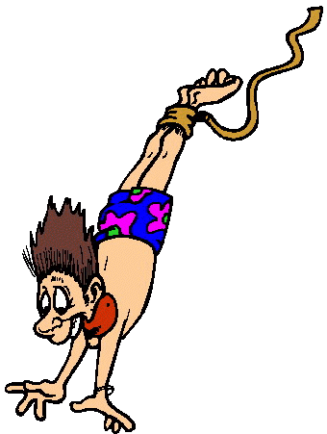 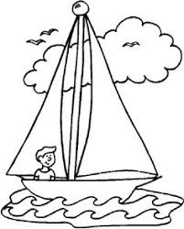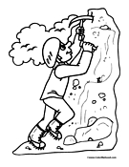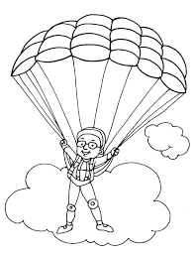

**1.) …………………………… 2.) …………………………… 3.) …………………………… 4.) ……………………………**

**B) Circle the correct word. (6x4p=24p)**

**1)** Sarah has **go / gone / went** to the shopping centre.

**2)** Rock climbing **is easier / more easy** than hang-gliding.

**3)** I prefer **dive / diving** with sharks.

**4)** To me, sailing is **gooder / better / more good** than caving.

**5)** I would rather go kayaking **than / to**  skydiving.

**6)** She hasn’t tried canoeing **just / yet / already.**

**C) Match the questions with the answers. (5x4p=20p)**

1. It was sunny and hot.
2. Yes, It was great.
3. In a small hotel.
4. For four days.
5. Next week.

**1)** **……………………..** How long did you stay there?

**2)** **……………………..** What was the weather like?

**3)** **……………………..** When are you going back?

**4)** **……………………..** Where did you stay?

**5)** **……………………..** Did you have fun in Bodrum?

**D) Complete the sentences. (5x4p=20p)**

bed and breakfast / souvenirs / fort / slippery / severe

**1)** You can learn about historic battles in a ………………………………………………………………..…………………… .

**2)** Kars is in the eastern Anatolia region and it has ……………………………………………………..……… weather.

**3)** You need to pay for your lunch and dinner in ……………………………………………………………….…… hotels.

**4)** I’m going to the Oxford Street to buy …………………………………………………………………………………..……. .

**5)** Ice climbing is dangerous because everywhere is …………………………………………………..…….……………. .

**E) Circle the correct choice. (5x4p=20p)**

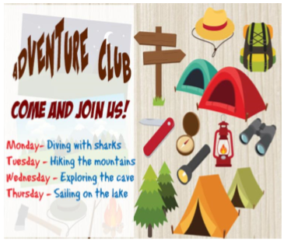

**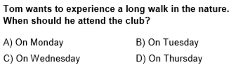  
  
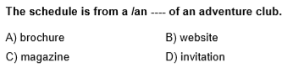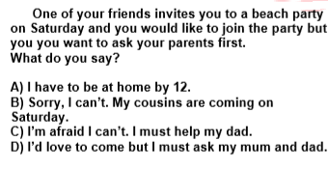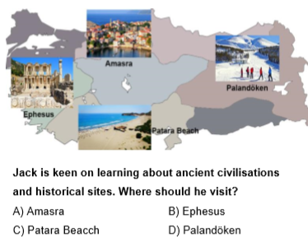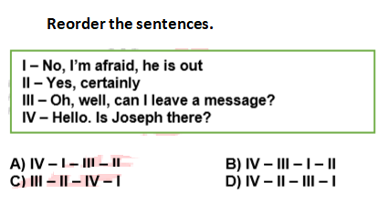**

**4.**

**3.**

**5.**

**2.**

**1.**

**5.**