NADİR TOLUN SECONDARY SCHOOL 2017-2018 EDUCATIONAL YEAR
5th GRADES 2nd TERM 2nd EXAM of ELECTIVE ENGLISH

Name / Surname:
Class / Number:

A- Choose the correct one. (6x4p=24p)
1) Verilen kelimelerle doğru olarak kurulmuş cümle hangisidir?  the farmer / milking / is / the cow  a) The farmer is the cow milking.  b) Milking the cow is the farmer.  c) The farmer is milking the cow.  d) The cow is milking the farmer. | 4) Hangi öğrencinin verdiği bilgi doğrudur?  Cansu Snakes can run.  Deniz Fish can’t swim.  Caner Elephants can climb the tree.  Derya Birds can fly.  a) Cansu b) Deniz c) Caner d) Derya
2) Hangi sayı yanlış yazılmıştır?  a) 135 – one hundred and thirty five  b) 267 – two hundred and sixty seven  c) 450 – four hundred and fifteen  d) 333 – three hundred and thirty three | 5) Cümleyi tamamlayan seçeneği işaretleyin.  Benjamin can …………………..…...….. a horse, …….…….…… weights and ………….… soccer.  a) go / play / do b) drive / skip / go  c) do / go / work d) ride / lift / play
3) Cümleyi tamamlayan seçeneği işaretleyin.  A: …………… is Peter doing?  B: He is cleaning the barn.  a) What b) Who c) Where d) What time | 6) Cümleyi tamamlayan seçeneği işaretleyin.  We ................. the Children’s Day on 23rd April.  a) perform b) wear c) decorate d) celebrate

B- Read the text and write TRUE or FALSE. (4x4p=16p)
Hi. I am Luis. My family and I live on a farm. We love animals. We always work hard on the farm. Now, my mom is feeding the hen and collecting some eggs. My father is cleaning the barn. My sister, Isabelle is milking the sheep. My little sister, Juliette is watching the ducks. She loves ducks.

1) (…………………….) Luis lives on a farm.

2) (…………………….) They don’t work hard.

3) (…………………….) His father is collecting eggs now..

4) (…………………….) Juliette loves ducks.
C- Write the names of the festivals. (3x4p=12p)
Chinese New Year / Youth and Sports Day / Republic Day

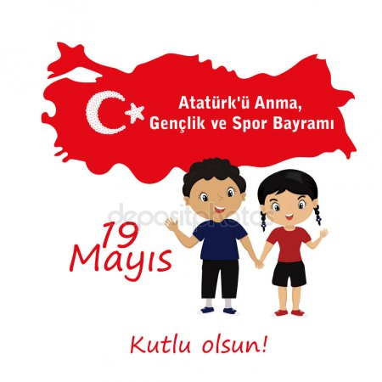

………………………… ………………………… …………………………
bird / cat / fish / rabbit / sheep
D- Read and find the animals. (5x4p=20p)

- It can swim. It is a small pet. ……………………………………………………….………………
- It is white. You can eat it. …………………………………….………..………...…………………
- It can fly. It is small. …………………………………...…………..………………………………
- It can jump. It likes carrots. …………………………………………………………………………
- It is a pet. It meows. ……………………………..…………………………………………………
E- Write the names of the sports and the activities. (5x4p=20p)
skiing / gymnastics / cycling / skateboarding / camping

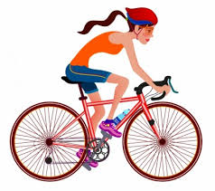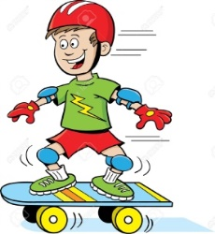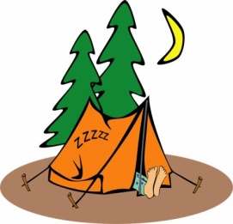
…………………….. …………………….. …………………….. …………………….. ……………………..

F- Answer the questions. (2x4p=8p)
1) 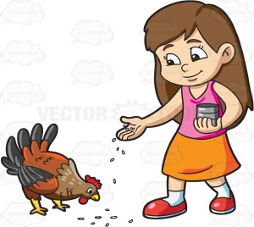 What is she doing?  .................................................................................. | 2) What are they doing?  ..................................................................................
Gizem YEŞİLOĞLU

