2017-2018 ACADEMIC YEAR NADİR TOLUN SECONDARY SCHOOL
8TH GRADES 2ND TERM 2ND WRITTEN EXAM of ENGLISH

NAME SURNAME:__________________________________ NUMBER:________ CLASS: 8/C MARK:_______

A) Complete the sentences. (10x2p=20p)
obey / take / chores / responsible / iron / mop / vacuum / dust / make / do

1. I’m …………………………….………… for setting the table. | 6. She’s going to ……………………..…..………. the laundry.
2. Did you ……………………………..…………….. the carpets? | 7. Whose turn is it to ……………………………….. the floor?
3. Everybody have to …………….….……………… the rules. | 8. Please ………………..…………..…………. out the rubbish.
4. I always …………………………………………..…….. my bed. | 9. Can you please ……………….……………… the furniture?
5. Can you please ……………………..……………… the shirt? | 10. We should share the …………….………………………….. .
B) Complete the sentences. (6x2p=12p)
explosion / replace / model / laboratory / test / experiment

1. The scientist was working in the …………………………………………………………………..……………….
2. There was an …………………………………………..………….………………. when the car hit the tree.
3. Bionic scientists can ………………………………….……………….. the body parts by artifical ones.
4. We’re doing an ……………………………………………………………….………………… in science lesson.
5. Do they …………………………………………………..…………………………. these products on animals?
6. First, he made a ……………………………………………………………….…………………. from cardboard.
C) Match the sentences with the pictures. (4x2p=8p)
1. He is exploring the space. 2. The nurse is vaccinating the little boy.
3. The boy is searching the net for a project task. 4. The scientist is conducting an experiment.
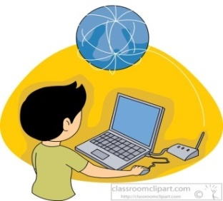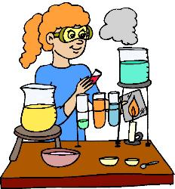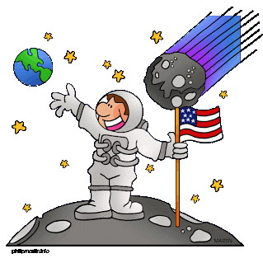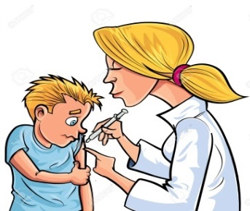

D) Circle the correct word. (4x2p=8p)
1. I can’t / don’t have to work. Let’s go to the cinema.
2. He must / mustn’t drive a car. He doesn’t have a licence.
3. Cars should / have to stop at the red traffic lights.
4. Can / Should you please set the table?
E) Match the people with their inventions and discoveries. (6x2=12p)
1. Felix Hoffman (……………………) | a) Gravity
2. Alexander Graham Bell (……………………) | b) X-rays
3. Wilhelm Roentgen (……………………) | c) Light bulb
4. Thomas Edison (……………………) | d) Penicilin
5. Alexander Fleming (……………………) | e) Telephone
6. Isaac Newton (……………………) | f) Aspirin
F) Match the words with the meanings. (5x2p=10p)
1. design (……………………) | a) study something a lot
2. invent (……………………) | b) make something new that nobody has made before
3. test (……………………) | c) learn something that you didn’t know
4. discover (……………………) | d) check something to see if it works
5. research (……………………) | e) draw or plan something that you will make or build
G) Write the names of the natural disasters. (5x2p=10p)
Earthquake / Flood / Lightning / Tornado / Drought

1) 2) 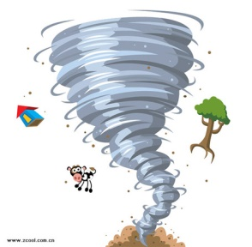 3) 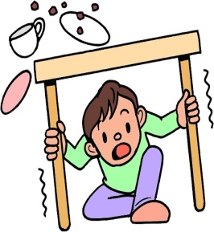 4) 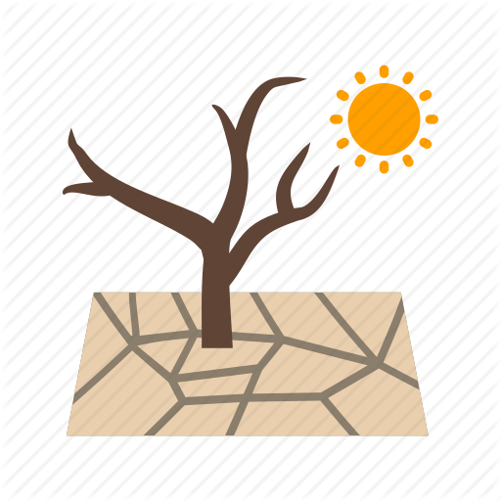 5)

H) Choose the correct answer. (10x2p=20p)
1-) Jenny: Shall we go to the cinema tonight?
Mark: I’d love to but I can’t.
Jenny: Shame. Why not?
Mark: I have to work tonight.
Jenny: Oh, I see. How about a BBQ party at my house next Saturday?
Mark: Sounds awesome. I have nothing to do that day. Jenny: It’s OK. See you.

Find the sentence in the dialogue that shows Mark’s excuse for refusing the offer.
A) Sounds awesome.
B) I have nothing to do that day.
C) I’d love to but I can’t.
D) I have to work tonight.

2-) Ted: How do you go to work? By bus or by train ?
Milner: I prefer train to bus. How about you ?
Ted: Me, too. It’s safer and cheaper.
Milner: You’re right. It is also as fast as the bus.

What is Ted’s opinion about train ?

A) He finds it too dangerous.
B) Going to work by train gets on his nerves.
C) He disagrees with Milner.
D) He thinks it is not expensive.

3-)
I live in a house with my flatmates but I am having some problems with them. The house is always dirty and I have to clean the house myself. They never help me. I can’t invite my friends. I feel embarrassed. What can I do?
Helen

What do you suggest for this situation?
A)It is your house.You must clean it.
B) You don’t have to vacuum the floor.
C) You should talk to your friends about it.
D) You must clean the house with your mother.

4-) Ayşin: Did you try any extreme sports on your holiday in Muğla?
Jack: Yes, I tried bungee-jumping for the first time.
Ayşin: ……………………………………………………………………
Jack: It was really entertaining. I really enjoyed .
A)What was it like?
B) Why did you try kayaking?
C) Which sports did they do?
D) How is the weather?

5-) Kemal: Where did you go on your last vacation?

Ali : I went to Bodrum with my classmates.

Kemal: What did you do there?

Ali : …………………………………………………….

A) It was hot and sunny.

B) The traditional dishes were delicious.

C) Many souvenirs.

D) I joined boat tours and swam in the sea.
6-) Lioyd wants to surf the Net. He starts up his computer,
but he can’t log on to websites. Which one may be broken?
A) modem B) scanner C) mouse D) speaker
CLASSROOM RULES
…………………………..
7-)
Which of the following can be in the list?

A)You must tidy your room.
B) You must respect your teachers.
C) You must help around the house.
D) You must make your bed.

8-)
Everything is made of atoms. They are very small particles. The centre of an atom is the nucleus. It contains protons and neutrons. Protons orbit around the nucleus. Protons have positive charge, electrons have negative charge. Electicity happens when electrons leave an atom.

Which one is false according to the text above?
A) A nucleus contains protons and neutrons.
B) Electrons have negative charge.
C) The nucleus is the centre of an atom.
D) Protons have no charge.

9-) Süleyman is an adrenalin junkie. He likes extreme sports. In his opinion, it is fascinating to explore cities from the air, so which activity should he prefer?

A) Hot air balloon B) Windsurfing
C) Scuba diving D) Rafting

10-) Your brother’s phone rings, but he can’t answer the phone because he isn’t available. You answer the phone. What do you say?

A) Hang on a minute, please. I’II get him.
B) I will get back to you later
C) He is worried about you. Are you ok?
D) He is busy now. Can you call him later?

