5.Sınıf İngilizce 8.Ünite (Fitness) Kazanım Testi
Name-Surname:
Soru 1  Can you .............. a bike?  Yes, I can.  A) ride B) play C) drive D) run | Soru 6  Thank you very much!  ........................  A) Sure B) Get well soon  C) You’re welcome D) See you
Soru 2  I .................. playing football.  A) can’t B) must C) like D) can | Soru 7  play ...................  Boşluğa aşağıdakilerden hangisi gelemez?  A) golf B) tennis C) diving D) volleyball
Soru 3  Penguins ................. walk fast but they ............. fly  A) can’t / can B) can / can  C) can’t / can’t D) can / can’t | Soru 8  ....................... drinking some lemonade?  A) Let’s B) When C) How about D) Where
Soru 4  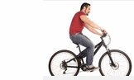  I like ............  A) running B) cycling C) jogging D) swimming | Soru 9  Jennifer goes ................... in winter.  A) ice-skating B) horse riding C) sailing D) skiing
Soru 5  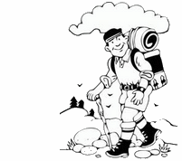  Let’s go..............  A) hiking B) swimming C) cycling D) jogging | Soru 10  “What is his favourite sport?”  Yukarıdaki soruyu görsele göre cevaplayınız.  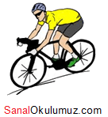  A) He likes running.  B) He likes cycling.  C) His favourite activity is hiking.  D) His favourite sport is diving.
Soru 11  Garry: Let’s go cycling.  Bob: No, I ............... ride a bike.  A) can B) can’t C) must D) should | Soru 16  My ................... activity is jogging. I go jogging every evening.  A) favourite B) hobby C) fitness D) exercise
Soru 12  Pam: I’m bored. Let’s do something.  Tom: .................. we go surfing?  A) How about B) Let’s C) Shall D) Must | Soru 17  A turtle ............ swim, but it .......... fly.  A) can / can’t B) can / can  C) can’t / can’t D) can’t / can
Soru 13  Kangaroos can .................  A) climb B) fly C) swim D) jump | Soru 18  Aşağıdakilerden hangisi diğerlerinden farklıdır?  A) weight-lifting B) windsurfing  C) sit-ups D) chin-ups
Soru 14  Let’s go jogging in the park.  No, I don’t like............  A) running B) swimming  C) climbing D) cycling | Soru 19  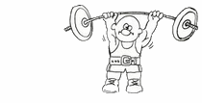  Terry can ................ weights.  A) lift B) run C) walk D) climb
Soru 15  Nicole is very fit. She ............. exercise every day.  A) do B) don’t C) doesn’t D) does | Soru 20  I ............... swim, but I can’t dive.  A) can B) can’t C) like D) must

Gizem Yeşiloğlu

