NAME …………………… SURNAME ………………………………….. CLASS ………. NO ……… DATE ……/……/……..
( B ) KAZIM ŞANÖZ SECONDARY SCHOOL 2nd TERM 2nd ELECTIVE ENGLISH EXAM
- Write the suitable words.(5*4=20 puan)

Burglar | Foot print | Magnifier | Security guard | Handcuff
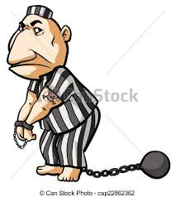
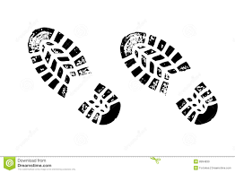

……………………………….. …………………………… …………………………………. ……………………….. …………………………….

- Write the numbers (10*2=20 puan)
18 | 29 | 92 | 56 | 245 | 658 | 712 | 2350 | 9100 | 14.876

Fifty six ……………. Two hundred forty five …………..
Fourteen thousand eight hundred seventy six ………………. Ninety two ………………..
Twenty nine ………………… Seven hundred twelve ………………
Eighteen ……………… Two thosand three hundred fifty ………………..
Six hundred fifty eight …………………. Nine thousand one hundred ……………………

- Write the suitable words.(10*2=20 puan)

Nurse | Dentist | Cook | Pilot | Hairdresser
Singer | Cleaner | Engineer | Vet | Driver

……………………………… ……………………………. ……………………………. ……………………… ……………………….
………………………. ………………………. ……………………….. ………………………. ………………………

- Read the paragraph and write TRUE or FALSE. (5*2=10 puan)
A BANK ROBBERY
Yesterday five criminals broke into and robbed the bank in our street.They stole one million dollars and some jewellery. The security cameras recorded the robbery.Some witnesses said that the robbers had guns in their hands. The securty guards called the police. The robbers wore black masks. The robbers escaped before the police came.The police investigated the crime scene.They found some clues: some fingerprints and footprints.In the end , the detectives caught and arrested the burglars , handcuffed them and put them in prison.

- Five criminals broke into the bank in our street. ………………..
- The police stole one million dollars and some jewellery. ……………….
- The robbers had masks in their hands. ………………
- The robbers wore black masks. ………………
- The detectives didn’t arrest the burglars and put them in prison. ………………….

- Match. (5*2=10 puan)
- What is your job? …………. A. In the shopping mall.
- Where do you work? ………… B. On weekends.
- When did you become a saleswoman? ………… C. No.
- Do you have an extra job? …………. D. Saleswoman.
- When do you work? ………… E. In 2008.

- Circle the correct one. (5*2=10 puan)

- Criminal : hırsız / suçlu
- Robber : dedektif / hırsız
- Gun : silah / dürbün
- Steal : çalmak / kaçmak
- Question : tutuklamak / sorgulamak

Leyla BERBER
ELT teacher

