Match the jobs with their definitions.
1. He acts in plays, films or TV shows. ………………………………………………… a waiter
2. She acts in plays, films or TV shows. ………………………………………………… a scientist
3. He/she plans buildings. ………………………………………………… a pilot
4. He/she draws and paints pictures. ………………………………………………… a tailor
5. He/she makes bread. ………………………………………………… a teacher
6. He/she cuts and styles hair. ………………………………………………… a mechanic
7. He/she looks after teeth. ………………………………………………… an actor
8. He/she looks after ill poeple. ………………………………………………… a football player
9. He/she drives a car. ………………………………………………… a singer
10. He/she works in a farm. ………………………………………………… a student
11. He/she puts out fires. ………………………………………………… a nurse
12. He/she plays football. ………………………………………………… a driver
13. He/she works in a garden. ………………………………………………… a vet
14. She works in the house for her family. ………………………………………………… a secretary
15. He/she repairs machines. ………………………………………………… an actress
16. He/she cares for sick people. ………………………………………………… a doctor
17. He/she drives an aeroplane. ………………………………………………… a farmer
18. He/she studies or practises science. ………………………………………………… a housewife
19. He/she types letters and works in an office.………………………………………………… an architect
20. He/she sings. (He/she has a nice voice.) ………………………………………………… a gardener
21. He/she studies and learn new things at school.………………………………………………… a barber
22. He/she teach new things at school. ………………………………………………… an artist
23. He/she makes clothes. ………………………………………………… a dentist
24. He/she works in a restaurant. ………………………………………………… a baker
25. He/she looks after ill animal. ………………………………………………… a fireman

Answer the questions.
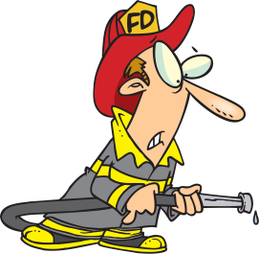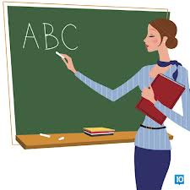
1. What is his job? 2. What is his job? 3. What is her job?
………………………………….. …………………………….. ……………………………..
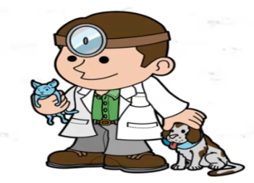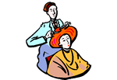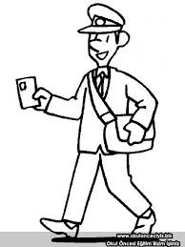
4. What is his job? 5. What is his job? 6. What is his job?
………………………………….. …………………………….. ……………………………..
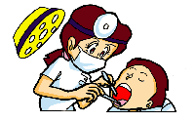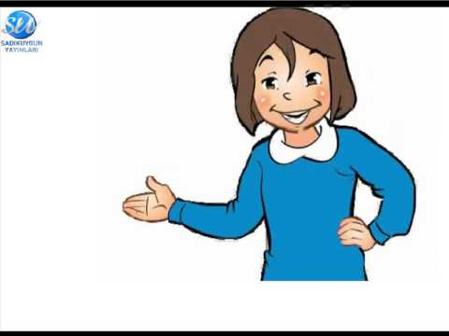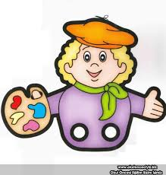
7. What is her job? 8. What is her job? 9. What is his job?
………………………………….. …………………………….. ……………………………..

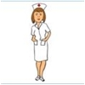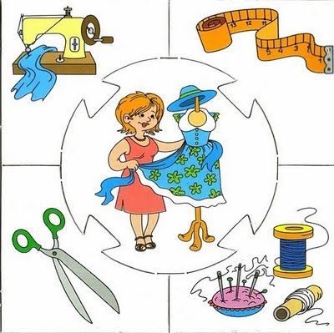
10. What is her job? 11. What is her job? 12. What is his job?
………………………………….. …………………………….. ……………………………..

