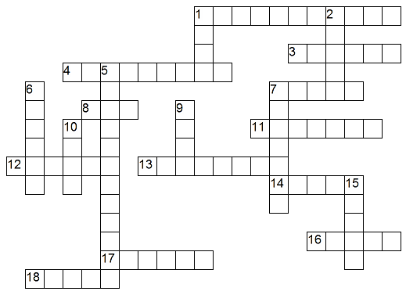

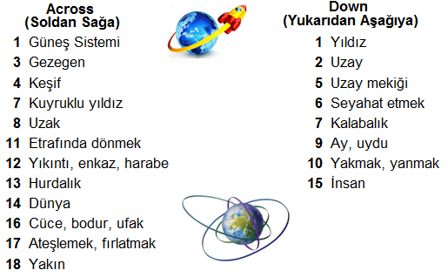

*Complete the sentences by using superlative forms of the adjectives.

1-Kızılırmak is ……………….……………………………………river in Turkey. (long)
2-A cheetah is …………………..………………………………….animal in the world. (fast)
3-Football is ………………………..……………………………....sport in Turkey. (popular)
4-Jupiter is ………………………….…………………………planet in the solar system. (big)
5-Venus is ………………………….………………………….planet in the solar system. (hot)
6-Mercury is …………………………….……………………….planet to the Sun. (close)
7-Human is …………………..…………………………life form on the Earth. (intelligent)
8-Russia is …………………..……..…………………………….country in the world. (large)
9-China is ……………………….………………………………country in the world. (crowded)
10-Cem Yılmaz is …………………..……………………………………..comedian. (funny)

*Comperative(-er than) or Superlative (the –est)
1-I think love is ……………………..……….……………………………money. (important)
2-My English is ………………………..…………………………………your English. (good)
3-February is …………………..………………….………………..month of the year. (short)
4-I think climbing is ……………..………..……….…………………..diving. (dangerous)
5-Erzurum is ……………………………….…..…………………………city in Turkey. (cold)
6-I think Rihanna is ………………….…………..………………………….Demi. (beautiful)
7-My room is ………………………………………………………room in our house. (small)
8-Maths is ……………………………….…………………………………..Science. (difficult)
9-Real Madrid is ……………………….………………………….F.C. in the world. (popular)
10-A blue whale is ……………………………………………………..an elephant. (heavy)
11-Efe is ……………………………………………………………student in the class. (tall)
12-Reality Shows are ………………………………………………….TV Series. (interesting)
13-“Survivor All Star” is………………………………………………..tv programme.(good)
14-I think Recep İvedik IV is …………………………………………Recep İvedik III. (funny)

FIND THE WORDS
1-O M O N ____________ 5-N M U A H _____________
2-L N P T A E ____________ 6-P S C A E _____________
3-O M C T E ____________ 7-U N B R _____________
4-R F A ____________ 8-S B R D E I _____________

