SIMPLE PRESENT TENSE
POSITIVE STATEMENT NEGATIVE STATEMENT

I  YOU  WE  THEY | get up early | everyday.
HE  SHE  IT | gets up early
I  YOU  WE  THEY | don’t get up early | everyday.
HE  SHE  IT | doesn’t get up early

QUESTION STATEMENT SHORT ANSWERS

Do | I  you  we  they | get up early?
Does | he  she  it | get up early?
Do | I  we  Yes,you do.  they | I  we  No,you don’t.  they
Does | he  Yes,she does.  it | he  No,she doesn’t.  it

NOTES:
In positive statement,
- I/We/You/They=Verb(Fiil yalın halde)
- He/She/It=Verb + -s
-es(Eğer fiilin sonu –o,-ch-sh,-x,-zz,-ss ile bitiyorsa) Sadece olumlu cümlede
-ies((Eğer fiilin sonu sessiz harf+-y ile bitiyorsa)

EXERCISE 1
Circle the correct form of the verbs.

1.I live/lives in a big house. 6.Do/Does he go to school by bus?
2.They swim/swims in the pool. 7.Do/Does you speak English?
3.He play/plays computer games. 8.Tom drink/drinks a lot of water.
4.It doesn’t /don’t fly. 9.Sarah wake/wakes up late on Sundays.
5.I don’t/doesn’t like fishing. 10.I watch/watches TV every evening.

EXERCISE 2
Rewrite new sentences according to the signs.
1.Do you swim everyday? | (+)
2.I make a sandwich every evening. | (?)
3.He comes home late. | (-)
4.She drives her car everyday. | (?)
5.He has a shower every morning. | (?)
6.They live in Canada. | (-)
7.She comes from Italy. | (?)
8.He drinks a cup of coffee every night. | (-)

ADVERBS OF FREQUENCY
%100 %0
________________________________________________________________
Always / Usually / Often / Sometimes /Hardly ever/ Rarely-Seldom /Never
Note:Sıklık zarflarını bir işi ne kadar sıklıkla yaptığımızı anlatmak istediğimizde kullanırız.Cümle içerisinde çoğunlukla fiilden önce,ancak am/is/are’dan sonra gelirler.
E.g: I always read books.
He sometimes plays football.
They are never late for school.
EXERCISE 3
Look at the table and make sentences.
 | Monday | Tuesday | Wednesday | Thursday | Friday | Saturday | Sunday
play basketball
watch TV
do exercise
go online
get up early
swim
e.g:She rarely plays basketball.
1………………………………………………………………… 4……………………………………………………………………………
2……………………………………………………………….. 5…………………………………………………………………………..
3………………………………………………………………. 6……………………………………………………………………………

HOW OFTEN….?(Ne sıklıkla….?)
Once(bir kez) Every day(hergün) Every year(her yıl)
Twice(iki kez) Every week(her hafta)
Three times(üç kez) Every month(her ay)
e.g:A:How often do you go to the pool?
B: I go to the pool twice a week.

EXPRESSING LIKES/DISLIKES
Expressing likes | Expressing dislikes
I’m crazy about | I can’t stand
I love | I can’t bear
I’m fond of | I hate
I like | I don’t like
I enjoy | I dislike
Note:Yukarıdaki kalıplardan sonra VERB+ing gelir.
e.g:I like drawing pictures.
I am fond of listening to music.
EXERCISE 4
Circle the correct option.
1.I don’t like/enjoy arguing over ridiculous issues.It makes me sick.
2.I hate/like his snobbish behaviour.He thinks that he rules the world.
3.I fond of/prefer hanging out with friends.
4.I love/hate rock music but my sister doesn’t like it.
5.I can’t stand/prefer listening to rock music.It ıs unbearable.

EXPRESSING PREFERENCES
PREFER+NOUN  (PREFER+İSİM) | We prefer pop concerts. | Biz pop konserlerini tercih ederiz.
PREFER+GERUND  (PREFER+-ing) | I prefer reading books. | Ben kitap okumayı tercih ederim.
PREFER+INFINITIVE with TO  (PREFER+to) | I prefer to buy trendy clothes. | Ben modaya uygun kıyafetler almayı tercih ederim.
PREFER+NOUN+to+NOUN  (PREFER+İSİM+to+İSİM) | I prefer ice-cream to chocolate. | Dondurmayı çikolataya tercih ederim.

Negative form of ‘prefer’:
1.I/We/You/They=don’t prefer I don’t prefer getting up early.
2.He/She/It=doesn’t prefer She doesn’t prefer listening to classical music.

Question form of ‘prefer’:
1.Do I/we/you/they prefer…..? Do you prefer tea to coffee?
2.Does he/she/it prefer………? Does Onur prefer cycling?

Short answers of ‘prefer’:
+Yes,I/we/you/they do. e.g:Do you prefer playing football?
DO +Yes,I do.
-No,I/we/you/they don’t. –No,I don’t.

+Yes,he/she/it does. e.g: Does she prefer swimming?
DOES +Yes,she does.
-No,he/she/it doesn’t. -No,she doesn’t.

EXERCISE 5
Look at the pictures and make sentences using ‘prefer’.
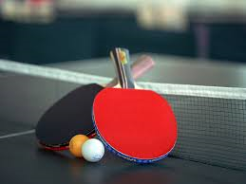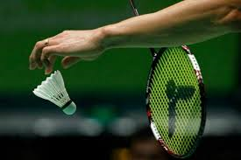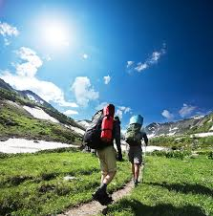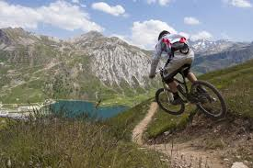
Table tennis Badminton Hiking Mountain biking
1.I prefer…………………………………………………………………….. 2.I prefer ……………………………………………………………….

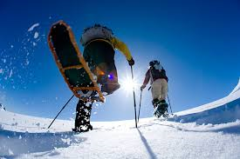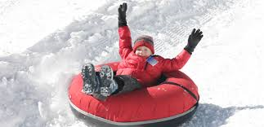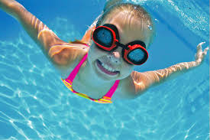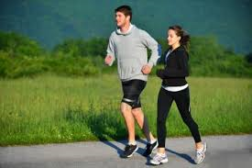
Snowshoeing Snowtubing Swimming Jogging
3.I prefer ………………………………………………………………….. 4.I prefer ……………………………………………………………………

Singing Dancing
5.I prefer …………………………………………………………..
STATING PERSONAL OPINIONS
- I think,  - I feel,  - I believe,  - I guess,  - In my opinion,  - Personally,  - I am sure/I am certain that,  - From my point of view. | hip hop music is | terrific.(mükemmel)  great.(müthiş)  impressive.(etkileyici)  interesting.(ilginç)  ridiculous.(gülünç,komik)  unbearable.(katlanılmaz)

What do you think of…….?(Ne düşünüyorsun?)
e.g:What do you think of my new dress?(Yeni elbisem hakkında ne düşünüyorsun?)
I think it is beautiful.(Bence güzel.)
NOTE:He/she/it thinks …….. . Ali thinks you are a true friend.

EXERCISE 6
Fill in the blanks with the given adjectives in the box.
Dangerous/powerful/good/expensive/handsome/exciting/delicious/boring

1.A:What do you think of the new restaurant?
B:I hink it is very …………… .I paid 200$ for a lunch.
2.A:What do you think of the lions?
B:I think they are………………… .They are the kings of the forests.
3.A:What does Susan think of me?
B:She thinks you are………………….. .She likes you.
4.A:What do you think of the new sitcom?
B:I think it is ………………………… .İ didn’t like it.
5.A:What do you think of bungee jumping?
B:I think it is …………………… .I can’t do it.
6.A:What do you think of this cake?
B:I think it is very ………………….. .Can I have one more piece?
7.A:Shall we go and watch the match today?
B:I think it isn’t a …………………… idea.I don’t like watching football matches.
8.A:What do you think about this book?
B:I think it is very …………………… .I finished it in a day.

