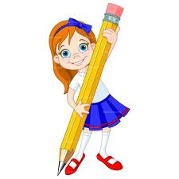
________________SECONDARY SCHOOL 2015-2016 EDUCATION YEAR
2ND TERM 1ST WRITTEN ENGLISH EXAM FOR 6TH GRADE
A. Resimlerle kelimeleri eşleştirin.(Kelimelerin yanına uygun harfi yazın.) (3x6=18pts)
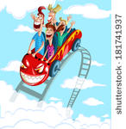

C
A
B

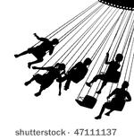
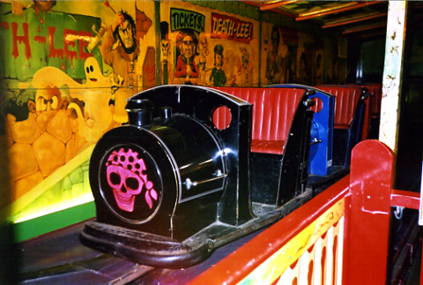
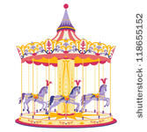

F
E
D

1) CARROUSEL: ………… 2) BIG WHEEL: ………….. 3) ROLLER COASTER: …………
4) GHOST TRAIN: ……….. 5) WAVE SWINGER :……… 6) BUMPER CARS: …………….

B) Match the activities with the pictures (Resimlerle aktiviteleri eşleştiriniz) (3x8=24 puan)
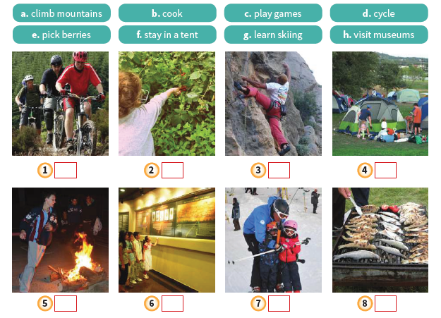

teacher architect hairdresser tailor doctor pilot
C) Write the occupations under the pictures. (Resimlerin altına meslekleri yazınız) (5x6=30 pts)

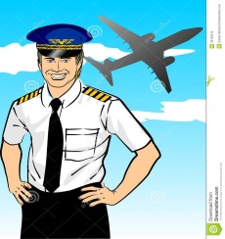
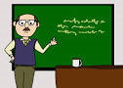
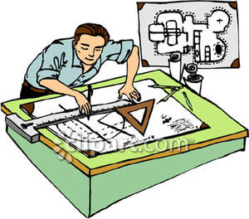
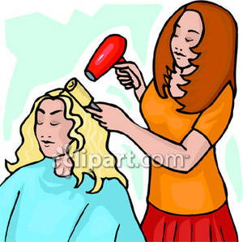
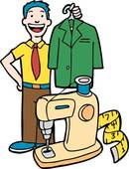
____________ ______________ ______________ _______________ _______________ _______________

D) Fill in the blanks with “was / were” (Boşlukları was/were kullanarak dolduralım. (2×5=10pts)
a) I___________ at home yesterday.
b) They ____________ at the park last weekend.
c) Mary ____________ at university 2 years ago .
d) Cem and Enes _________ at the cinema last Sunday.
e) He ___________ in Antalya last summer.

E) Read the descriptions and circle the correct job (Tanımlara göre doğru mesleği işaretleyin) (3×6=18pts)
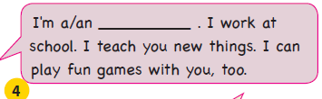
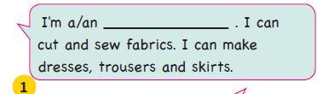

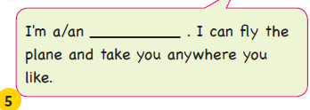
a) Dentist b) Tailor c) Teacher d) Nurse a) Pilot b) Mechanic c) Police d) Teacher
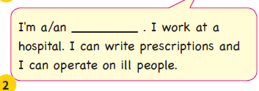

a) Pilot b) Technician c) Nurse d) Engineer
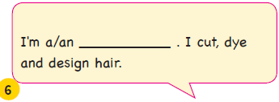
a) Doctor b) Architect c) Mechanic d) Lawyer
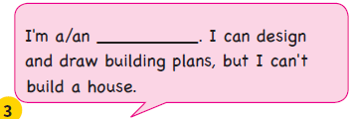

a) Tailor b) Hairdresser c) Worker d) Doctor
a) Hairdresser b) Teacher c) Architect d) Cook
Good Luck

