2016-2017 EDUCATIONAL YEAR ÇAĞLAYAN MIDDLE SCHOOL
2017-2018 EDUCATION YEAR ŞEHİT BURAK ZOR RELIGIOUS VOCATIONAL
SECONDARY SCHOOL 2ND TERM 1ST ENGLISH EXAM FOR 7TH GRADE
NAME&SURNAME: ___________________________
NUMBER:____ A
7TH GRADERS 2nd TERM 1st WRITTEN ENGLISH EXAM
Name/Surname: (A) Class/Number:
A) Resimlerin altına uygun kelimeleri yazınız.( 11*1=11)
a- coffee reading b- halloween party c- fortune teller d- wedding party e- gift f- blue bead g- palm reading h- birthday party j- fortune cookies k-breaking mirror l-pharmacy

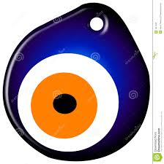
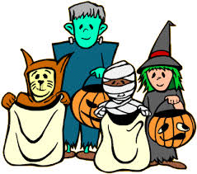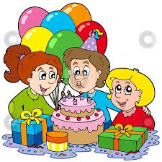
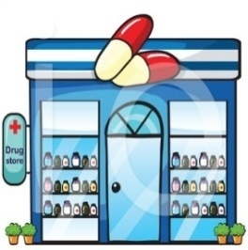
1.__________2.___________ 3._____________ 4.________ 5._________
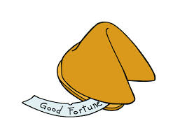
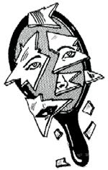
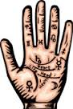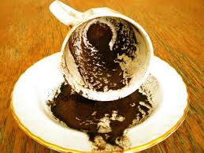
6._______ 7.______ 8.___________ 9. _______ 10.__________11._______
B) Doğru Olanı Yuvarlak İçine Alın. (5x2 = 10 )
1. There are a few /a little money in my pocket.
2. We have got some / any butter in the fridge.
3. I haven’t got some / any problem with him.
4. Kamil has got a lot of / any books in his bag.
5. How many / much milk is there for breakfast?

C) Boşlukları “Why don’t” / “Let’s” / “should” /
"How about"ile doldurun. (5x2 =10 p)
- _______________having a picnic together?
- ______________ you join my birthday party ?
- ________________we watch a horror movie?
- _____________________ listen to music.
- We ___________ study hard to pass the exam.

D.Boşlukları doldurun(10x2=20p).
bank – hospital – chemist’s – bakery – florist – shoeshop – grocery – fire station – school - library
1.If I need medicine ,I’ll goto a ___________.6. I goto a _____________ to buy trainers.
2.I go to a _______________to buy bread. 7.Students goto _______ to learn new things.
3. I visit ill people in a ______________ . 8. I goto a ___________________ to buy eggs.
4. I go to a _______________to buy flowers. 9. I goto a __________ to study quietly.
5. I will go to a __________ if I need money. 10.There are a lot of fire engines at the ________.
- Yes, you will.
- I will wear a witch costume.
- Ten books.
- Once a week.
- a little, please.
- I went to Istanbul.
- It’s on 18th of April, 2002.
- A hat.
- How much butter do you need for the cake?
- When is your birthday?
- Will I be happy in future?
- What will you wear at fancy dress party?
- What will you buy your sister for her birthday?
- How many books will you buy ?
- How often do you go to cinema?
- Where did you go last year?
E) Sorulara uygun cevapları yandaki tablodan seçip rakamını boşluğa yazınız.(8x2=16p)

F.Eşanlamlıları eşleştiriniz(7*2=14) G) Kelimelerle tamamlayınız. (5*2=10 pts)
1.gift (…..) drink
2. join (…..) candy
3. give a party (…..) present
4. select (…..) participate in
5. sweet (…..) throw a party
6. beverage (…..) choose
7. fancy dress (…..) costume

*cake *invitation *party hats
*smoothie *candles

F) Davetiyeye göre soruları cevaplayınız.(5x3p:1
- My sister likes ………. She usually wears them.
- We eat ………………… and drink…………… at party.
- I have got an …………………… card for wedding.
- Buy some …………………. . We will light them
at the party.

H.Cümleleri birleştiriniz (3*3=9)

1.I went to gym. I want to have fit body.

_______________________________

2.Burcu went to shopping mall. She tried new clothes.

___________________________________________

3.He always goes to cafe.He has some desert.

___________________________________

GOOD LUCK
ÖZLEM ZORLU
TEACHER OF ENGLISH

