2017-2018 EDUCATION YEAR ŞEHİT BURAK ZOR RELIGIOUS VOCATIONAL
SECONDARY SCHOOL 2ND TERM 1ST ENGLISH EXAM FOR 6TH GRADE
NAME&SURNAME: ___________________________
NUMBER:____ B

A)Fill in the blanks with the Simple Past form of the verbs.(V₂) 10x2=20
- I _________ (not/drink) a lot of water yesterday.
- ____Mary ____ (wake) up early in the morning?
- They _______ (play) chess yesterday evening.
- Last week we________ (have) an exam.
- My sister ________ (buy) a car last year .

6)We _________ (visit) our granny yesterday.
7)You _________ (study) a lot 2 days ago.
8)Tom and I _________(go) to the concert last night.
9)My mother _________ (cook) delicious meals.
10)What ________ (be) you last week?

_____policeman
_____architect
_____accountant
_____fireman
_____soldier
_____tailor
_____dentist
_____hairdresser
_____doctor
_____postman
B)Match the jobs with their definitions (10x2=20p)
1) ………………………………. can keep and examine financial records of a company
2) They protect the country from the enemies...............................
3) I am a/an ………………. I fight crime and arrest the criminals .
4) I am a/an ………………. I can design and draw building plans
5) I can cut and sew fabric I’m a/an......................................
6) They put out fires and rescue people. ................................
7) I am a/an ………………..... I can cut,dye and design hair.
8) He cares for people’s teeth. ................................
9) I can write prescriptions I’m a/an......................................
10) I can deliver letters.I’m a/an......................................

C)Match them . (10x1=10p)
1. 3.000.000 ______a. three million
2. 1920 ______ b. seventeen hundred
3. 5000 ______ c. two thousand and fifteen
4. 100 _____ d. eighteen and eighty one
5. 1908 ______ e. nineteen oh eight
6. 2015 ______ f. two thousand
7. 1989 ______ g. nineteen and eighty nine
8. 1881 ______ h. a hundred
9. 1700 ______i. nineteen and twenty
10. 2000 ______j. five thousand

D)Match the questions and answers.(Soru ve cevapları eşleştirin)(6x2=12pts)
- How was your last holiday? _______a- It was great.
- Where were you? _______b- I was with my friends.
- Who was with you? _______c- I was in Antalya
- How was the weather? _______d- I learned swimming and diving.
- What did you do? _______e-. Last summer.
- When did you go there? _______f- It was warm and sunny.
E)Match the pictures with the given words. 10x2=20
kidnapper - robber - fingerprints – chase-jewelry - guilty –solve case - teeth impression - magnifier – case scene
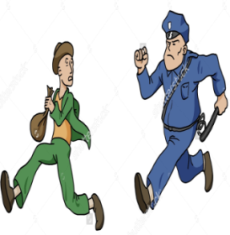
____________ ______________ _____________ ____________ _____________ 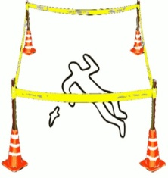 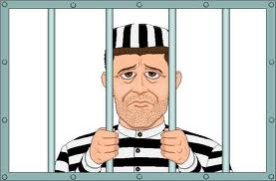
_________ ____________ _______________ ______________ ______________
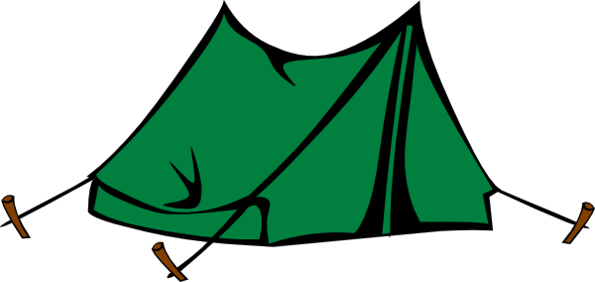
F) Find the (6x2=12pt)
1.I stayed in a ______on my vacation .
a) tent b)house c) hotel d)museum

2.A:__________ is the fun fair?
B:It is at 9 o’clock.

a)When b)What c)What time d)Where

3.She ____________ yesterday.
a)climbed mountains b)learned diving
c) picked flowers
d) went hiking

4.Jenny: ______ was your holiday?
Annie: It was fantastic.
- Why b- where c-which d- how

5.I’m Tom and I’m a student. I go to school on Monday,Tuesday and Wednesday. I’m off at weekend
Verilen bilgilere göre hangisi yanlıştır?

- He works three days in a week.
- He doesn’t work at weekends.
- He learns new things at school.
- He works on Saturday and Sunday.

6.My children played in the garden _________ .
a) everyday b)two days ago c) today d) now

7 A:______ you play football yesterday?
B:No,I __________.
a)Did / didn’t b)Do / don’t
c)Did / did d)Did / was

8.I am a pilot. I _____ in London now but I ____ in New York yesterday.
- am/were b) are/was
c)is/was d) am/was

9. . Michael _____ twenty-seven years old now.
He ______ twenty-five two years ago .
a) is / was b) did / was
c) is / is d) is / did

1. 6.
2. 7.
3. 8.
4. 9.
5.

ÖZLEM ZORLU

