**2015-2016 ACADEMIC YEAR ___________________ SECONDARY SCHOOL**

**2nd TERM 1st WRITTEN EXAM FOR 6th GRADES**

Name & Surname :_________________________________________ Date:___/__/2016

Number : _______

Class :____ /____ Mark:__________

1. **Match the words with the pictures. (Resimlerle kelimeleri eşleştiriniz.) 6x2=12**

Sunbathing - .Skiing - Snowboarding - Shopping - Hiking - Diving - Sightseeing

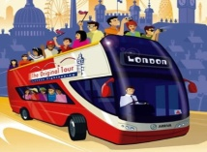 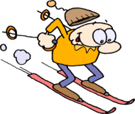    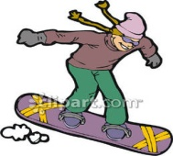

____________ ______________ ______________ ______________ _______________ _______________

1. **Fill in the blanks with the Simple Past form of the verbs.(V2) 10x2=20**
2. We _________ (visit) our granny yesterday.
3. _________ (be) you at the theatre 2 days ago?
4. Tom and I _________ (go) to the concert last night.
5. A.G. Bell __________ (invent) the telephone.
6. What ________ (be) the weather like last week?
7. I _________ (drink) a lot of water yesterday.
8. Mary ________ (get) up early in the morning.
9. They ________ (play) chess yesterday evening.
10. Last week we________ (have) an exam.
11. My sister _________ (be) very clumsy last year .

|  |  |  |
| --- | --- | --- |
| **C)** | **Write the jobs under the pictures (10X2=20)** |  |
| artist – singer – pilot - architect – tailor  Açıklama: jobs flashcards ile ilgili görsel sonucu Açıklama: http://images.clipartpanda.com/tailor-clipart-gg54395815.jpg Açıklama: http://clipart.mrdonn.org/other_icon.gif Açıklama: http://www.people-clipart.com/people_clipart_images/artist_painting_a_still_life_0521-1010-3117-4857_SMU.jpg Açıklama: http://images.clipartpanda.com/singer-clipart-singer.gif  1.____________ 2.________________ 3.______________ 4.________________ 5._____________ | | |

|  |
| --- |
| Nurse, Architect, Pilot, Hairdresser, Mechanic, Teacher, Tailor, Astronaut, Doctor, Secretary,  **D) Write appropriate jobs (Boşluklara uygun mesleği yazınız) (10x2=20pts)**  1- __________ can cut and dye hair. 6- ____________ can draw building plans.  2- __________ can mend cars. 7- ____________ can teach you new things  3- __________ can cut and sew fabric. 8- ____________ can write prescriptions.  4- __________ can use a spaceship 9- __________can write letters, answers phones  5- __________ can fly the plane. 10- ____________ can look after ill people. |

|  |
| --- |
| **E) Fill in the blanks with the sentences given below. Boşlukları verilen cümlelerle doldurunuz.(4x2=8 pts)**  ***\*Where are you at the moment?***  ***\*What is your name?***  ***\*What are you doing?***  ***\*What is the person doing now?***  **Officer:** Hello! Officer Nick is speaking.  **Angel:** Hello! I... I need your help. Somebody wants to  break into our house.  **Officer:**  (1)______________________________  **Angel:** It's Angel Wind.  **Officer:** (2) _______________________________  **Angel:** In the living room.  **Officer:** (3) _______________________________  **Angel:** We are doing homework.  **Officer:** (4) _______________________________  **Angel:** I think he is at the window. Oh, no! He is walking to the door. I can hear his foot steps.  **Officer:** Keep calm and stay on line. The police will be there in a few minutes. |

**F) Match the pictures with the given words. (resimleri verilen kelimelerle eşleştiriniz). 10x2=20**

Burglar - robber - fingerprints - painting - jewelry - prison - detective - footprints - magnifier - van

  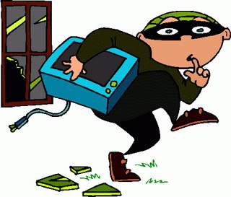  

_____________ ______________ _____________ ____________ _______________

   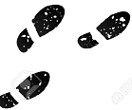 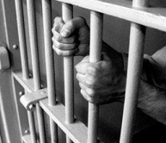

___________ ____________ _______________ ______________ ______________

 ELÇİN ECE

ELT