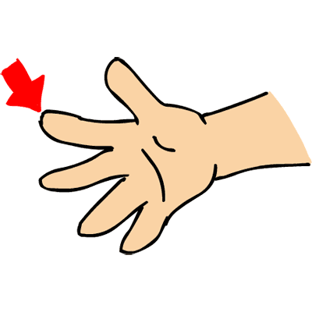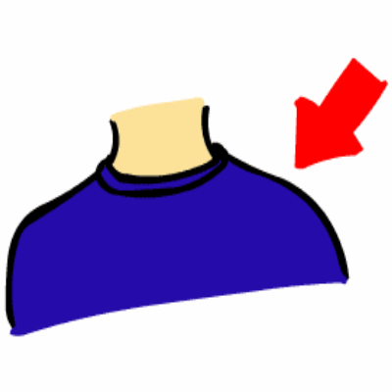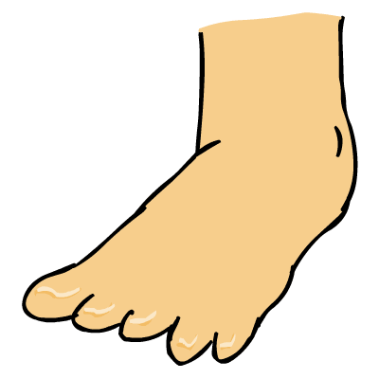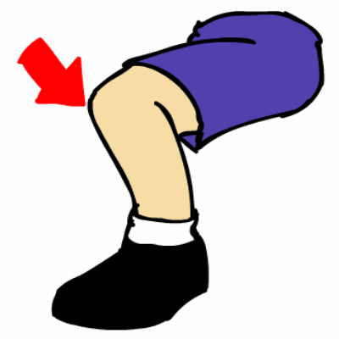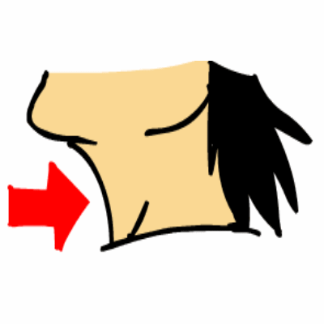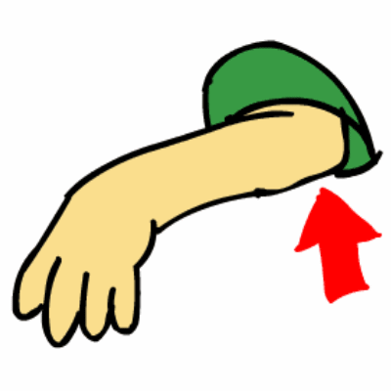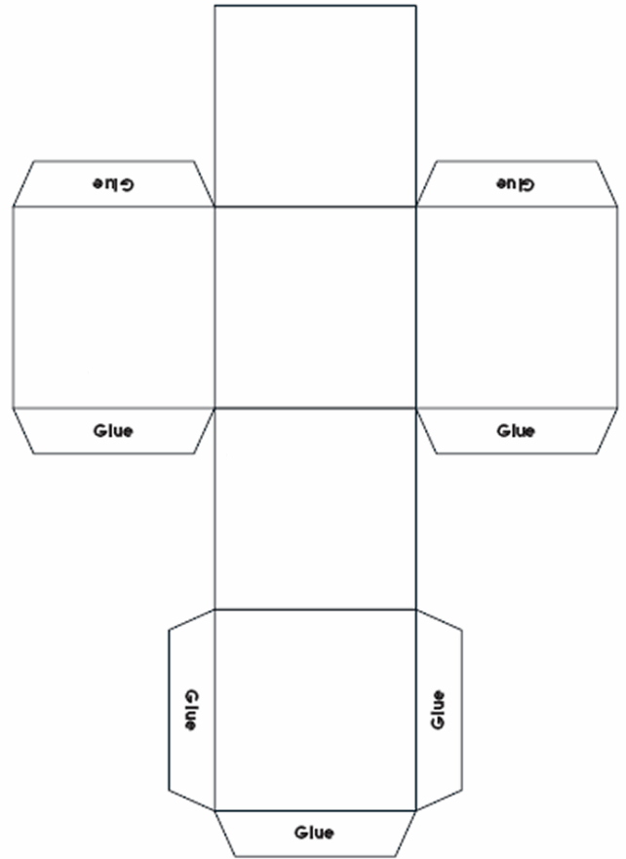

Name: _______________________________________________________

**Roll your die until you have rolled each body part four times. Say the name of each body part every time it comes up.**

|  |  |  |  |  |
| --- | --- | --- | --- | --- |
| http://www.esl-kids.com/worksheets/images/bodyparts/neck.gifneck |  |  |  |  |
| http://www.esl-kids.com/worksheets/images/bodyparts/knee.gifknee |  |  |  |  |
| http://www.esl-kids.com/worksheets/images/bodyparts/elbow.gifelbow |  |  |  |  |
| http://www.esl-kids.com/worksheets/images/bodyparts/foot.gif  feet or toes |  |  |  |  |
| http://www.esl-kids.com/worksheets/images/bodyparts/shoulder.gifshoulder |  |  |  |  |
| http://www.esl-kids.com/worksheets/images/bodyparts/finger.giffingers |  |  |  |  |