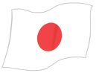

**1. Where is she from?**

**She is from Japan_______.**

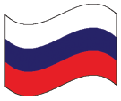**(Russia)  
  
2. Where is she from?**

**……….…………..………………………….…**



**3. Where is she from?**

**……….…………..………………………….…**



**4. Where is he from?**

**……….…………..………………………….  
  
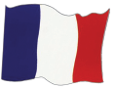(France)  
  
5. Where is he from?**

**……….…………..………………………….…**



**6. Where is he from?**

**……….…………..………………………….…  
  
**

**7. Where is he from?**

**……….…………..………………………….…**

**(Italy)**

**8. Where is he from?**

**……….…………..………………………….…**

** (Germany)**

**9. Where is he from?**

**……….…………..………………………….…**



**10. Where is she from?**

**……….…………..………………………….…**



**11. Where is she from?**

**……….…………..………………………….…**



**12. Where is he from?**

**……….…………..………………………….…**



**14. Where is Ayşegül from?**

**……….…………..………………………….…**



**15. Where is Murat from?**

**……….…………..………………………….…**



**16. Where are you from?**

**……….…………..…………………………….**