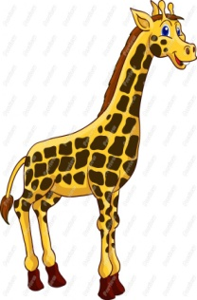
1- The giraffe is _______ .
a) tall
b) fast
c) old

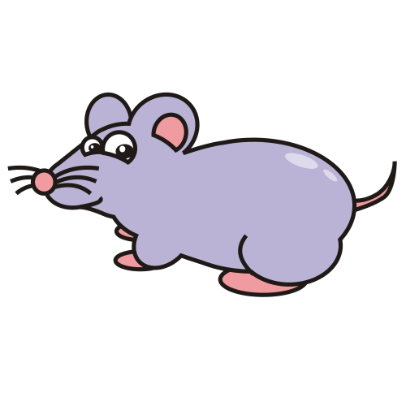
2- The mouse is ________ .
a) fat
b) tall
c) small

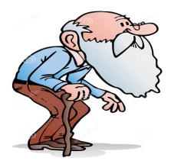
3- Jack is ________ .
a) young
b) slim
c) old

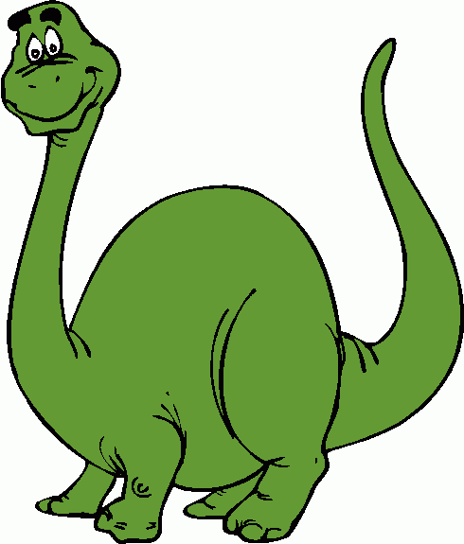
4- The dinosaur is _________ .
a) slow
b) big
c) short

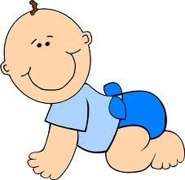
5- Ali is a ________ baby.
a) strong
b) young
c) big

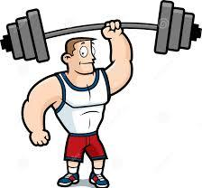
6- My brother is ________ .
a) strong
b) fast
c) small

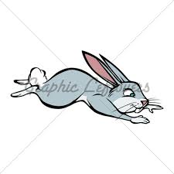
7- The rabbit is very ________ .
a) fat
b) fast
c) tall

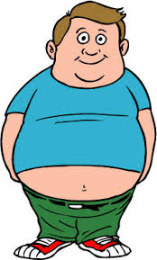
8- My father is very ________ .
a) slim
b) young
c) fat

9- Mehmet is a ________ boy.
a) short
b) big
c) old

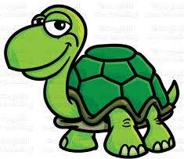
10- Turtle is a ________ animal.
a) fast
b) slow
c) young

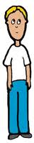
11- He is a ________ student.
a) strong
b) fast
c) slim

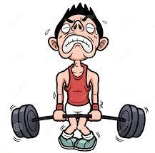
12- My cousin is very ______ .
a) weak
b) strong
c) fat

