JOBS (MESLEKLER)

I | Ben | My | Benim
You | Sen, Siz | Your | Senin, sizin
We | Biz | Our | Bizim
They | Onlar | Their | Onların
He | O (erkek) | His | Onun
She | O (bayan) | Her | Onun
It | O ( Cansız varlık, bitki ve hayvan) | Its | Onun

Yandaki tabloya bakarak öznelerin karşısına sahiplik belirten ifadeleri 4’er kez yazınız.
I  my | You  your |  | We  our | They  their | He  his | She  her |  |  | It  its

Aşağıdaki boşlukları your/his/her ile doldurunuz.
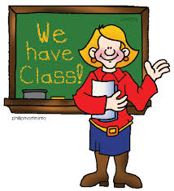  What’s ………. job?  She is a teacher. | What’s ……….job?  He is an engineer. | 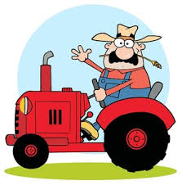What’s ……… job?  He is a farmer. | What’s ………. Job?  I’m a doctor. | 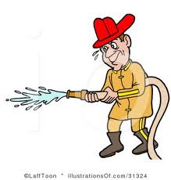  What’s ……….job?  He is a fireman.
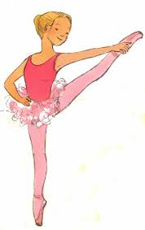What’s ……..job?  She is a dancer. | 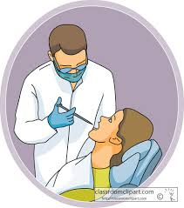  What’s ………job?  I’m is a dentist. | 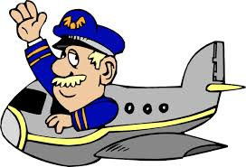  What’s ……..job?  He is a pilot. | What’s ………job?  She is a lawyer. | 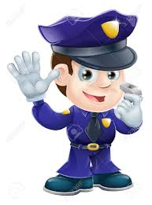  What’s ……...job?  I’m a policeman.

Aşağıdaki boşlukları I/He/She ile doldurunuz.
What’s his job?  …….. is a waiter. | What’s her job?  ……….is a waitress. | 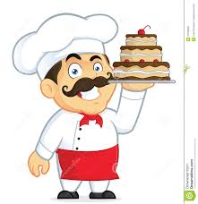  What’s your job?  ………’m a chef. | 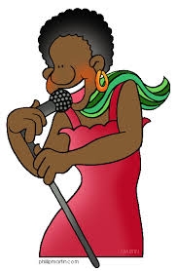  What’s her job?  ………is a singer. | What’s his job?  ……….is a businessman.
What’s his job?  ……….is a vet. | 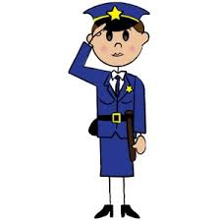  What’s your job?  …….’m a policewoman. | What’s his hob?  …….is a postman. | 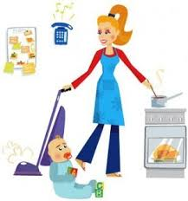  What’s her job?  ……….is a housewife. | 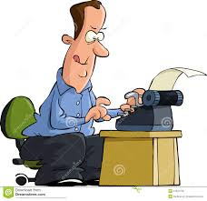  What’s your job?  ………..’m a writer.

Aşağıdaki boşlukları do/does ile doldurunuz.
What ……..you do?  I’m a vet. | What ………she do?  She is a singer. | What ………..he do?  He is a pilot. | What ………..she do?  She is a teacher. | What ………..you do?  I’m a farmer.
What ……… he do?  He is a dentist. | What ……..she do?  She is a dancer. | What ……..you do?  I’m a writer. | What ……….he do?  He is an engineer. | What ………she do?  She is a housewife.

