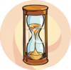

**Match the columns**

**3.15 It’s five forty**

**2.45 It’s two ten**

**2.10 It’s two forty - five**

**6.55 It’s seven five**

**1.50 It’s six fifty - five**

**6.20 It’s three fifteen**

**5.40 It’s one fifty**

**7.05 It’s six twenty**

**Write the time in numbers**

**It’s ten fifteen→ ___________**

**It’s five eight → _____________**

**It’s nine twenty - seven→ ____________**

**It’s ten two → _____________**

**It’s twenty thirty → ___________**

**It’s four twenty-five → __________**

**Complete the sentences**

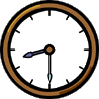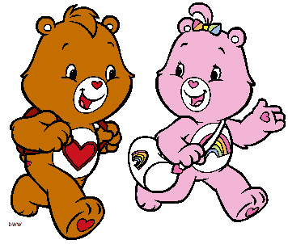

**A. Excuse me, what time is it?**

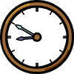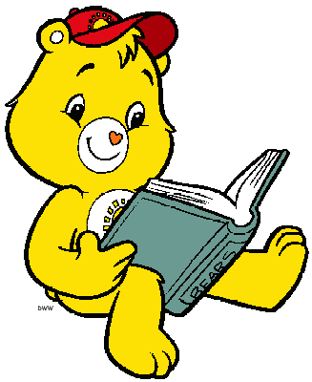

**It’s ___________________________**

**B. Can you tell me the time?**

**B**

**It’s ___________________________**

**C**

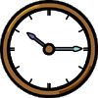

**C. What time is it?**

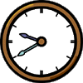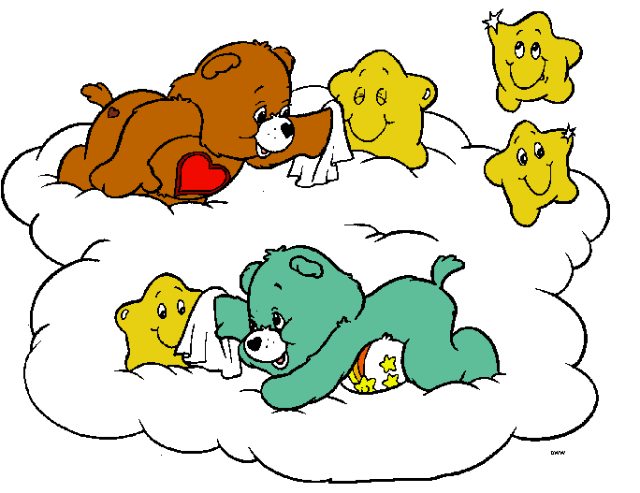

**It’s __________________________**

**D. What time is it, please?**

**It’s __________________________**

**A**

**D**

**Choose the right time**

**It’s six o’clock**

**It’s twelve o’clock**

**It’s three fifty**

**It’s two fifty**

**It’s two tirty**

**It’s two o’clock**

**Answer the questions (Yes, it is or No, it isn’t)**

|  |  |  |
| --- | --- | --- |
| **10.15** | **Is it ten fifteen?** |  |
| **12.00** | **Is it twelve o’clock?** |  |
| **09.10** | **Is it ten nine?** |  |
| **12.20** | **It is twelve twenty?** |  |
| **3.15** | **Is it fifteen three?** |  |
| **2.30** | **Is it three thirty?** |  |
| **4.40** | **Is it four fourty?** |  |
| **6.45** | **Is it seven fourty - five?** |  |

