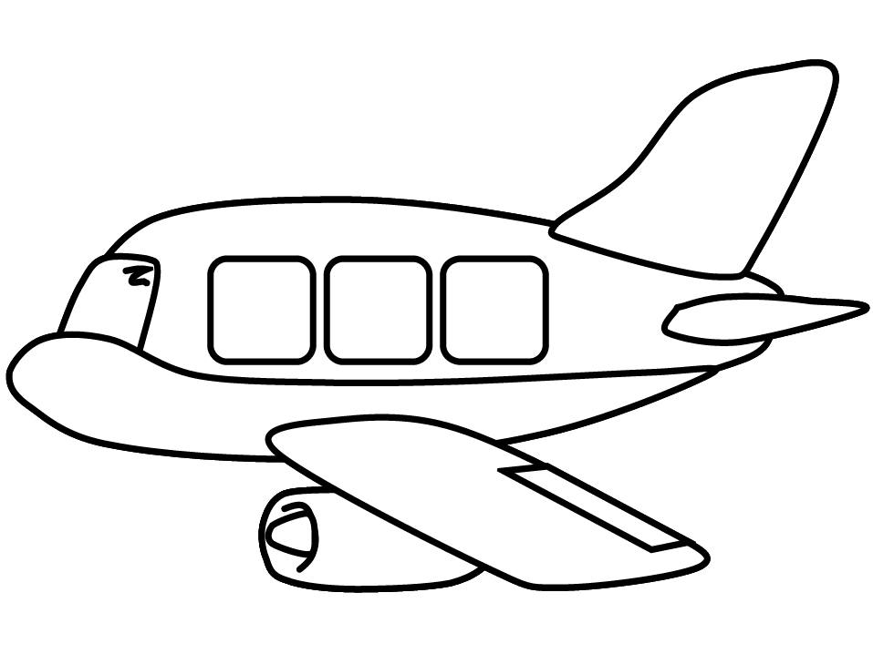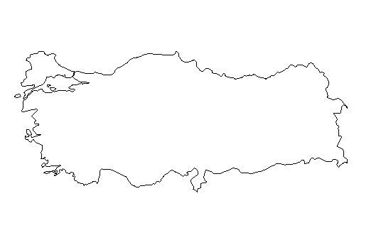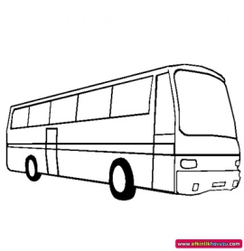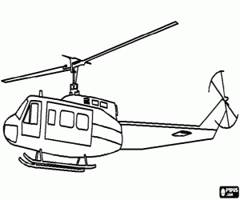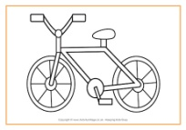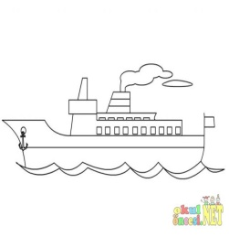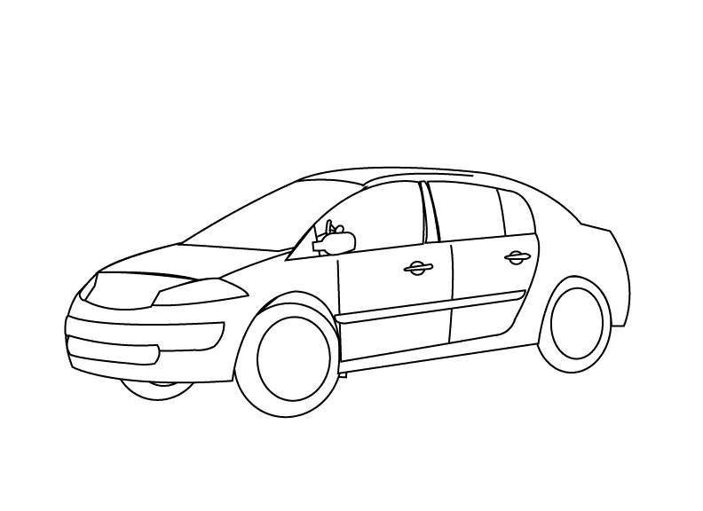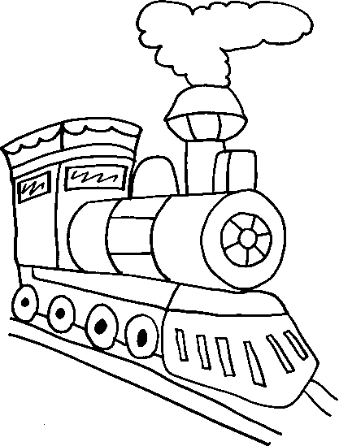

1. How can I go to İstanbul?

…………………………………………………………………………………………………

1. How can I go to İzmir?

……………………………………………………………………………………………………

1. How can I go to Ankara?

…………………………………………………………………………………………………

1. How can I go to Samsun?

…………………………………………………………………………………………………

1. How can I go to Rize?

……………………………………………………………………………………………………..

6. How can I go to Sivas?

……………………………………………………………………………………………………..

7) How can I go to Van? ………………………………………………………………………..

6. How can I get to Malatya? ……………………………………………………………………………………………….

7. How can I get to Van? ………………………………………………………………………………………………….…..

İSTANBUL

ANKARA

SİVAS

VAN

RİZE

SAMSUN

İZMİR