AŞAĞIDAKİ YERLERİN İSİMLERİNİ KUTUDAN YAZINIZ
CITY --- BANK --- PARK --- MUSEUM --- CARNIVAL
HOSPITAL --- ZOO --- SHOPPING CENTRE --- SCHOOL --- CAMPUS BOOK SHOP --- CINEMA

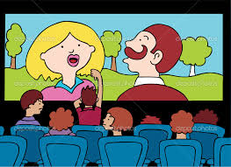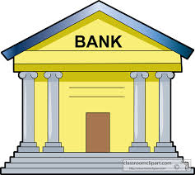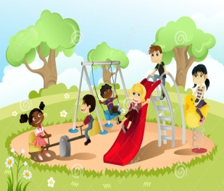
.............................. ................................ ..............................
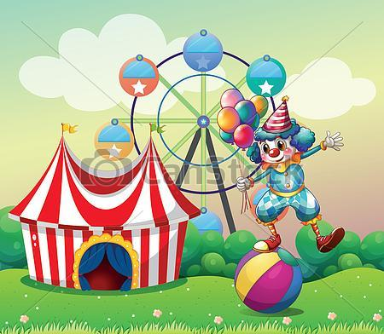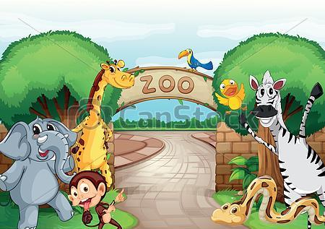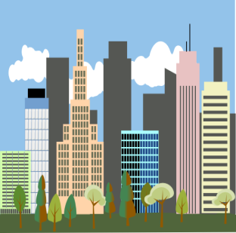
.............................. ................................. ...............................
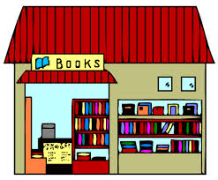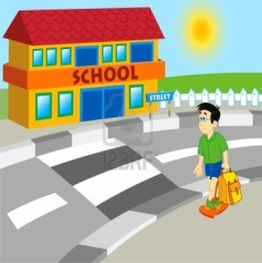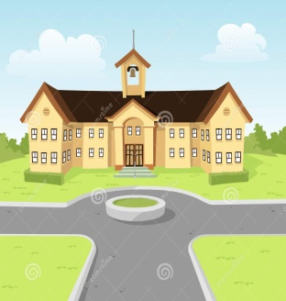
.............................. .................................... ...............................
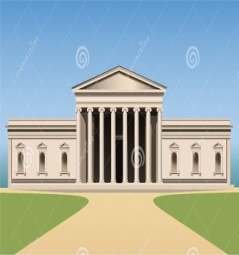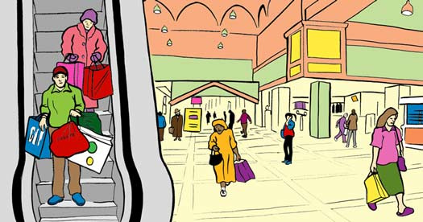
............................... ..................................... ................................
AŞAĞIDAKİ YERLERİN İSİMLERİNİ KUTUDAN YAZINIZ
CITY --- BANK --- PARK --- MUSEUM --- CARNIVAL
HOSPITAL --- ZOO --- SHOPPING CENTRE --- SCHOOL --- CAMPUS BOOK SHOP --- CINEMA

.............................. ................................ ..............................
.............................. ................................. ...............................
.............................. .................................... ...............................
............................... ..................................... ................................

