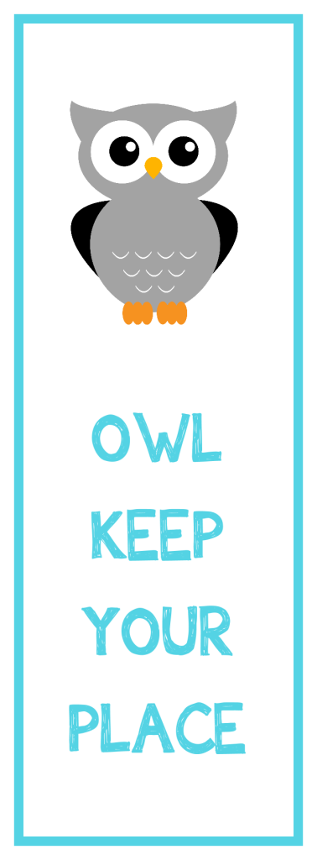

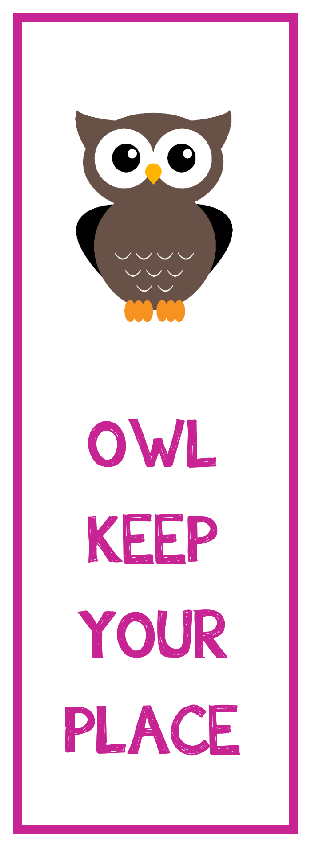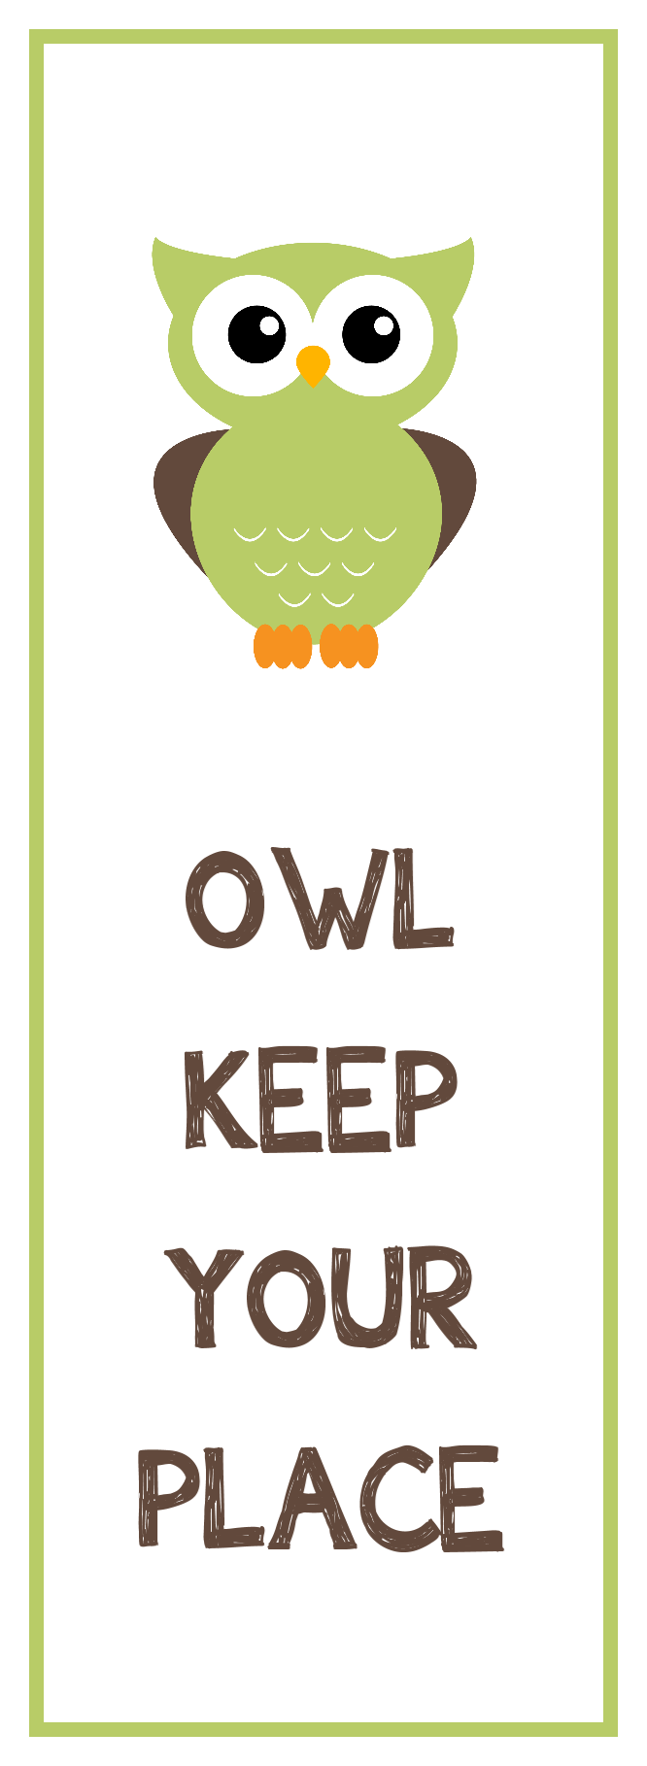

IRREGULAR VERBS

|  |  |
| --- | --- |
| am,is,are (olmak) | **was,were** |
| break (kırmak) | **broke** |
| bring (getirmek) | **brought** |
| buy (satın almak) | **bought** |
| come (gelmek) | **came** |
| cut (kesmek) | **cut** |
| do (yapmak) | **did** |
| drink ( içmek) | **drank** |
| eat (yemek) | **ate** |
| go (gitmek) | **went** |
| give (vermek) | **gave** |
| have (sahip olmak) | **had** |
| leave (ayrılmak) | **left** |
| make (yapmak) | **made** |
| read (okumak) | **read** |
| ride (binmek) | **rode** |
| sleep (uyumak) | **slept** |
| swim (yüzmek) | **swam** |
| speak (konuşmak) | **spoke** |
| take (almak) | **took** |
| write (yazmak) | **wrote** |

IRREGULAR VERBS

|  |  |
| --- | --- |
| am,is,are (olmak) | **was,were** |
| break (kırmak) | **broke** |
| bring (getirmek) | **brought** |
| buy (satın almak) | **bought** |
| come (gelmek) | **came** |
| cut (kesmek) | **cut** |
| do (yapmak) | **did** |
| drink ( içmek) | **drank** |
| eat (yemek) | **ate** |
| go (gitmek) | **went** |
| give (vermek) | **gave** |
| have (sahip olmak) | **had** |
| leave (ayrılmak) | **left** |
| make (yapmak) | **made** |
| read (okumak) | **read** |
| ride (binmek) | **rode** |
| sleep (uyumak) | **slept** |
| swim (yüzmek) | **swam** |
| speak (konuşmak) | **spoke** |
| take (almak) | **took** |
| write (yazmak) | **wrote** |

IRREGULAR VERBS

|  |  |
| --- | --- |
| am,is,are (olmak) | **was,were** |
| break (kırmak) | **broke** |
| bring (getirmek) | **brought** |
| buy (satın almak) | **bought** |
| come (gelmek) | **came** |
| cut (kesmek) | **cut** |
| do (yapmak) | **did** |
| drink ( içmek) | **drank** |
| eat (yemek) | **ate** |
| go (gitmek) | **went** |
| give (vermek) | **gave** |
| have (sahip olmak) | **had** |
| leave (ayrılmak) | **left** |
| make (yapmak) | **made** |
| read (okumak) | **read** |
| ride (binmek) | **rode** |
| sleep (uyumak) | **slept** |
| swim (yüzmek) | **swam** |
| speak (konuşmak) | **spoke** |
| take (almak) | **took** |
| write (yazmak) | **wrote** |

IRREGULAR VERBS

|  |  |
| --- | --- |
| am,is,are (olmak) | **was,were** |
| break (kırmak) | **broke** |
| bring (getirmek) | **brought** |
| buy (satın almak) | **bought** |
| come (gelmek) | **came** |
| cut (kesmek) | **cut** |
| do (yapmak) | **did** |
| drink ( içmek) | **drank** |
| eat (yemek) | **ate** |
| go (gitmek) | **went** |
| give (vermek) | **gave** |
| have (sahip olmak) | **had** |
| leave (ayrılmak) | **left** |
| make (yapmak) | **made** |
| read (okumak) | **read** |
| ride (binmek) | **rode** |
| sleep (uyumak) | **slept** |
| swim (yüzmek) | **swam** |
| speak (konuşmak) | **spoke** |
| take (almak) | **took** |
| write (yazmak) | **wrote** |

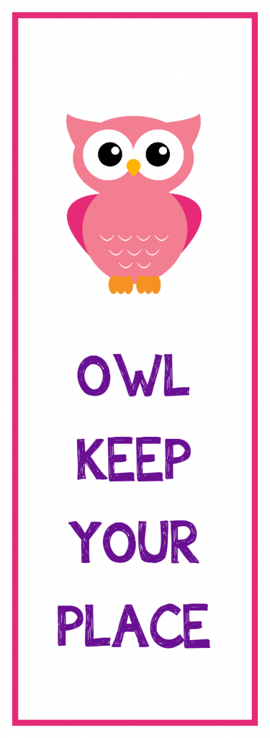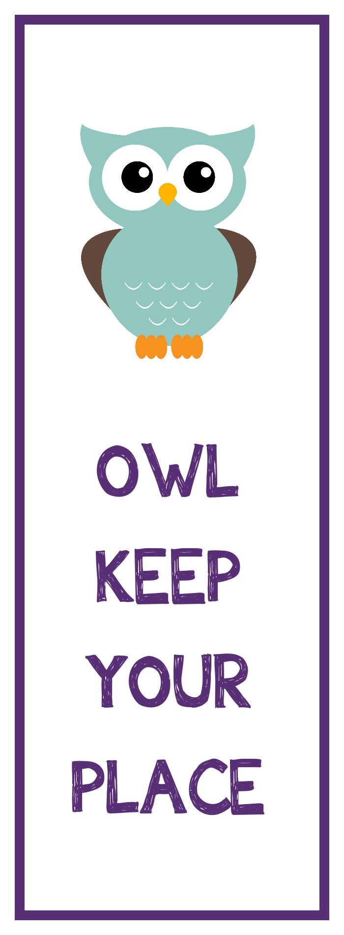

IRREGULAR VERBS

|  |  |
| --- | --- |
| am,is,are (olmak) | **was,were** |
| break (kırmak) | **broke** |
| bring (getirmek) | **brought** |
| buy (satın almak) | **bought** |
| come (gelmek) | **came** |
| cut (kesmek) | **cut** |
| do (yapmak) | **did** |
| drink ( içmek) | **drank** |
| eat (yemek) | **ate** |
| go (gitmek) | **went** |
| give (vermek) | **gave** |
| have (sahip olmak) | **had** |
| leave (ayrılmak) | **left** |
| make (yapmak) | **made** |
| read (okumak) | **read** |
| ride (binmek) | **rode** |
| sleep (uyumak) | **slept** |
| swim (yüzmek) | **swam** |
| speak (konuşmak) | **spoke** |
| take (almak) | **took** |
| write (yazmak) | **wrote** |

IRREGULAR VERBS

|  |  |
| --- | --- |
| am,is,are (olmak) | **was,were** |
| break (kırmak) | **broke** |
| bring (getirmek) | **brought** |
| buy (satın almak) | **bought** |
| come (gelmek) | **came** |
| cut (kesmek) | **cut** |
| do (yapmak) | **did** |
| drink ( içmek) | **drank** |
| eat (yemek) | **ate** |
| go (gitmek) | **went** |
| give (vermek) | **gave** |
| have (sahip olmak) | **had** |
| leave (ayrılmak) | **left** |
| make (yapmak) | **made** |
| read (okumak) | **read** |
| ride (binmek) | **rode** |
| sleep (uyumak) | **slept** |
| swim (yüzmek) | **swam** |
| speak (konuşmak) | **spoke** |
| take (almak) | **took** |
| write (yazmak) | **wrote** |

IRREGULAR VERBS

|  |  |
| --- | --- |
| am,is,are (olmak) | **was,were** |
| break (kırmak) | **broke** |
| bring (getirmek) | **brought** |
| buy (satın almak) | **bought** |
| come (gelmek) | **came** |
| cut (kesmek) | **cut** |
| do (yapmak) | **did** |
| drink ( içmek) | **drank** |
| eat (yemek) | **ate** |
| go (gitmek) | **went** |
| give (vermek) | **gave** |
| have (sahip olmak) | **had** |
| leave (ayrılmak) | **left** |
| make (yapmak) | **made** |
| read (okumak) | **read** |
| ride (binmek) | **rode** |
| sleep (uyumak) | **slept** |
| swim (yüzmek) | **swam** |
| speak (konuşmak) | **spoke** |
| take (almak) | **took** |
| write (yazmak) | **wrote** |

IRREGULAR VERBS

|  |  |
| --- | --- |
| am,is,are (olmak) | **was,were** |
| break (kırmak) | **broke** |
| bring (getirmek) | **brought** |
| buy (satın almak) | **bought** |
| come (gelmek) | **came** |
| cut (kesmek) | **cut** |
| do (yapmak) | **did** |
| drink ( içmek) | **drank** |
| eat (yemek) | **ate** |
| go (gitmek) | **went** |
| give (vermek) | **gave** |
| have (sahip olmak) | **had** |
| leave (ayrılmak) | **left** |
| make (yapmak) | **made** |
| read (okumak) | **read** |
| ride (binmek) | **rode** |
| sleep (uyumak) | **slept** |
| swim (yüzmek) | **swam** |
| speak (konuşmak) | **spoke** |
| take (almak) | **took** |
| write (yazmak) | **wrote** |





IRREGULAR VERBS

|  |  |
| --- | --- |
| am,is,are (olmak) | **was,were** |
| break (kırmak) | **broke** |
| bring (getirmek) | **brought** |
| buy (satın almak) | **bought** |
| come (gelmek) | **came** |
| cut (kesmek) | **cut** |
| do (yapmak) | **did** |
| drink ( içmek) | **drank** |
| eat (yemek) | **ate** |
| go (gitmek) | **went** |
| give (vermek) | **gave** |
| have (sahip olmak) | **had** |
| leave (ayrılmak) | **left** |
| make (yapmak) | **made** |
| read (okumak) | **read** |
| ride (binmek) | **rode** |
| sleep (uyumak) | **slept** |
| swim (yüzmek) | **swam** |
| speak (konuşmak) | **spoke** |
| take (almak) | **took** |
| write (yazmak) | **wrote** |

IRREGULAR VERBS

|  |  |
| --- | --- |
| am,is,are (olmak) | **was,were** |
| break (kırmak) | **broke** |
| bring (getirmek) | **brought** |
| buy (satın almak) | **bought** |
| come (gelmek) | **came** |
| cut (kesmek) | **cut** |
| do (yapmak) | **did** |
| drink ( içmek) | **drank** |
| eat (yemek) | **ate** |
| go (gitmek) | **went** |
| give (vermek) | **gave** |
| have (sahip olmak) | **had** |
| leave (ayrılmak) | **left** |
| make (yapmak) | **made** |
| read (okumak) | **read** |
| ride (binmek) | **rode** |
| sleep (uyumak) | **slept** |
| swim (yüzmek) | **swam** |
| speak (konuşmak) | **spoke** |
| take (almak) | **took** |
| write (yazmak) | **wrote** |

IRREGULAR VERBS

|  |  |
| --- | --- |
| am,is,are (olmak) | **was,were** |
| break (kırmak) | **broke** |
| bring (getirmek) | **brought** |
| buy (satın almak) | **bought** |
| come (gelmek) | **came** |
| cut (kesmek) | **cut** |
| do (yapmak) | **did** |
| drink ( içmek) | **drank** |
| eat (yemek) | **ate** |
| go (gitmek) | **went** |
| give (vermek) | **gave** |
| have (sahip olmak) | **had** |
| leave (ayrılmak) | **left** |
| make (yapmak) | **made** |
| read (okumak) | **read** |
| ride (binmek) | **rode** |
| sleep (uyumak) | **slept** |
| swim (yüzmek) | **swam** |
| speak (konuşmak) | **spoke** |
| take (almak) | **took** |
| write (yazmak) | **wrote** |

IRREGULAR VERBS

|  |  |
| --- | --- |
| am,is,are (olmak) | **was,were** |
| break (kırmak) | **broke** |
| bring (getirmek) | **brought** |
| buy (satın almak) | **bought** |
| come (gelmek) | **came** |
| cut (kesmek) | **cut** |
| do (yapmak) | **did** |
| drink ( içmek) | **drank** |
| eat (yemek) | **ate** |
| go (gitmek) | **went** |
| give (vermek) | **gave** |
| have (sahip olmak) | **had** |
| leave (ayrılmak) | **left** |
| make (yapmak) | **made** |
| read (okumak) | **read** |
| ride (binmek) | **rode** |
| sleep (uyumak) | **slept** |
| swim (yüzmek) | **swam** |
| speak (konuşmak) | **spoke** |
| take (almak) | **took** |
| write (yazmak) | **wrote** |



IRREGULAR VERBS

|  |  |
| --- | --- |
| am,is,are (olmak) | **was,were** |
| break (kırmak) | **broke** |
| bring (getirmek) | **brought** |
| buy (satın almak) | **bought** |
| come (gelmek) | **came** |
| cut (kesmek) | **cut** |
| do (yapmak) | **did** |
| drink ( içmek) | **drank** |
| eat (yemek) | **ate** |
| go (gitmek) | **went** |
| give (vermek) | **gave** |
| have (sahip olmak) | **had** |
| leave (ayrılmak) | **left** |
| make (yapmak) | **made** |
| read (okumak) | **read** |
| ride (binmek) | **rode** |
| sleep (uyumak) | **slept** |
| swim (yüzmek) | **swam** |
| speak (konuşmak) | **spoke** |
| take (almak) | **took** |
| write (yazmak) | **wrote** |

IRREGULAR VERBS

|  |  |
| --- | --- |
| am,is,are (olmak) | **was,were** |
| break (kırmak) | **broke** |
| bring (getirmek) | **brought** |
| buy (satın almak) | **bought** |
| come (gelmek) | **came** |
| cut (kesmek) | **cut** |
| do (yapmak) | **did** |
| drink ( içmek) | **drank** |
| eat (yemek) | **ate** |
| go (gitmek) | **went** |
| give (vermek) | **gave** |
| have (sahip olmak) | **had** |
| leave (ayrılmak) | **left** |
| make (yapmak) | **made** |
| read (okumak) | **read** |
| ride (binmek) | **rode** |
| sleep (uyumak) | **slept** |
| swim (yüzmek) | **swam** |
| speak (konuşmak) | **spoke** |
| take (almak) | **took** |
| write (yazmak) | **wrote** |

IRREGULAR VERBS

|  |  |
| --- | --- |
| am,is,are (olmak) | **was,were** |
| break (kırmak) | **broke** |
| bring (getirmek) | **brought** |
| buy (satın almak) | **bought** |
| come (gelmek) | **came** |
| cut (kesmek) | **cut** |
| do (yapmak) | **did** |
| drink ( içmek) | **drank** |
| eat (yemek) | **ate** |
| go (gitmek) | **went** |
| give (vermek) | **gave** |
| have (sahip olmak) | **had** |
| leave (ayrılmak) | **left** |
| make (yapmak) | **made** |
| read (okumak) | **read** |
| ride (binmek) | **rode** |
| sleep (uyumak) | **slept** |
| swim (yüzmek) | **swam** |
| speak (konuşmak) | **spoke** |
| take (almak) | **took** |
| write (yazmak) | **wrote** |

IRREGULAR VERBS

|  |  |
| --- | --- |
| am,is,are (olmak) | **was,were** |
| break (kırmak) | **broke** |
| bring (getirmek) | **brought** |
| buy (satın almak) | **bought** |
| come (gelmek) | **came** |
| cut (kesmek) | **cut** |
| do (yapmak) | **did** |
| drink ( içmek) | **drank** |
| eat (yemek) | **ate** |
| go (gitmek) | **went** |
| give (vermek) | **gave** |
| have (sahip olmak) | **had** |
| leave (ayrılmak) | **left** |
| make (yapmak) | **made** |
| read (okumak) | **read** |
| ride (binmek) | **rode** |
| sleep (uyumak) | **slept** |
| swim (yüzmek) | **swam** |
| speak (konuşmak) | **spoke** |
| take (almak) | **took** |
| write (yazmak) | **wrote** |





IRREGULAR VERBS

|  |  |
| --- | --- |
| am,is,are (olmak) | **was,were** |
| break (kırmak) | **broke** |
| bring (getirmek) | **brought** |
| buy (satın almak) | **bought** |
| come (gelmek) | **came** |
| cut (kesmek) | **cut** |
| do (yapmak) | **did** |
| drink ( içmek) | **drank** |
| eat (yemek) | **ate** |
| go (gitmek) | **went** |
| give (vermek) | **gave** |
| have (sahip olmak) | **had** |
| leave (ayrılmak) | **left** |
| make (yapmak) | **made** |
| read (okumak) | **read** |
| ride (binmek) | **rode** |
| sleep (uyumak) | **slept** |
| swim (yüzmek) | **swam** |
| speak (konuşmak) | **spoke** |
| take (almak) | **took** |
| write (yazmak) | **wrote** |

IRREGULAR VERBS

|  |  |
| --- | --- |
| am,is,are (olmak) | **was,were** |
| break (kırmak) | **broke** |
| bring (getirmek) | **brought** |
| buy (satın almak) | **bought** |
| come (gelmek) | **came** |
| cut (kesmek) | **cut** |
| do (yapmak) | **did** |
| drink ( içmek) | **drank** |
| eat (yemek) | **ate** |
| go (gitmek) | **went** |
| give (vermek) | **gave** |
| have (sahip olmak) | **had** |
| leave (ayrılmak) | **left** |
| make (yapmak) | **made** |
| read (okumak) | **read** |
| ride (binmek) | **rode** |
| sleep (uyumak) | **slept** |
| swim (yüzmek) | **swam** |
| speak (konuşmak) | **spoke** |
| take (almak) | **took** |
| write (yazmak) | **wrote** |

IRREGULAR VERBS

|  |  |
| --- | --- |
| am,is,are (olmak) | **was,were** |
| break (kırmak) | **broke** |
| bring (getirmek) | **brought** |
| buy (satın almak) | **bought** |
| come (gelmek) | **came** |
| cut (kesmek) | **cut** |
| do (yapmak) | **did** |
| drink ( içmek) | **drank** |
| eat (yemek) | **ate** |
| go (gitmek) | **went** |
| give (vermek) | **gave** |
| have (sahip olmak) | **had** |
| leave (ayrılmak) | **left** |
| make (yapmak) | **made** |
| read (okumak) | **read** |
| ride (binmek) | **rode** |
| sleep (uyumak) | **slept** |
| swim (yüzmek) | **swam** |
| speak (konuşmak) | **spoke** |
| take (almak) | **took** |
| write (yazmak) | **wrote** |

IRREGULAR VERBS

|  |  |
| --- | --- |
| am,is,are (olmak) | **was,were** |
| break (kırmak) | **broke** |
| bring (getirmek) | **brought** |
| buy (satın almak) | **bought** |
| come (gelmek) | **came** |
| cut (kesmek) | **cut** |
| do (yapmak) | **did** |
| drink ( içmek) | **drank** |
| eat (yemek) | **ate** |
| go (gitmek) | **went** |
| give (vermek) | **gave** |
| have (sahip olmak) | **had** |
| leave (ayrılmak) | **left** |
| make (yapmak) | **made** |
| read (okumak) | **read** |
| ride (binmek) | **rode** |
| sleep (uyumak) | **slept** |
| swim (yüzmek) | **swam** |
| speak (konuşmak) | **spoke** |
| take (almak) | **took** |
| write (yazmak) | **wrote** |