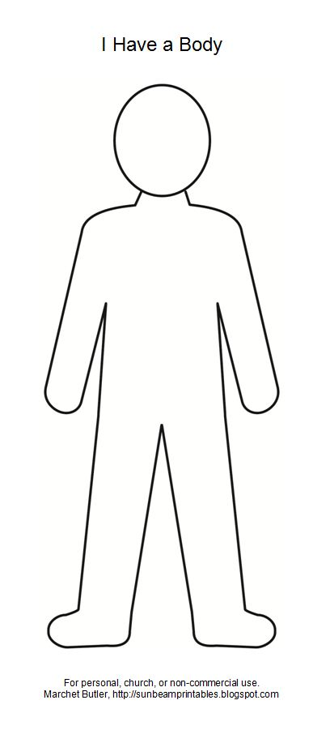

*HOW DO YOU DESCRIBE YORUSELF?*

PHYSICALLY

PERSONALLY

MYSELF