Aşağıda verilen resimlere uygun cevabı örnekteki gibi yuvarlak içine alınız.
Örnek:
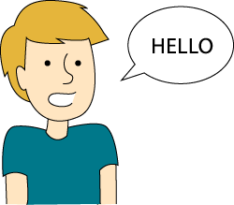 3- 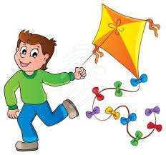
Can he speak English? Can he fly a kite?
A) Yes,he can. A) No,she can't.
B) Yes,she can. B) Yes,she can.
C) No he can't. C) Yes,he can.
1- 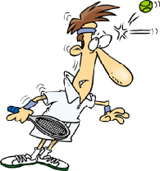 4- 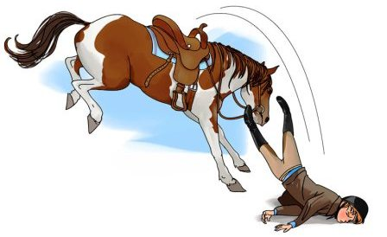
Can he play tennis? Can she ride a horse?
A) Yes,she can. A) Yes,he can.
B) No,he can't. B) No,she can't.
C) No,she can't. C) No,he can't.
2- 5- 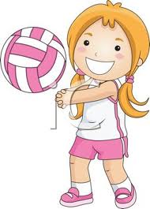
Can she swim? Can she play volleyball?
A) No,she can't. A) Yes,she can.
B) No,he can't. B) No,she can't.
C) Yes,she can. C) Yes,he can.
Aşağıdaki ifadelere örneklerdeki gibi uygun şekilde cevap veriniz.
Örnek:
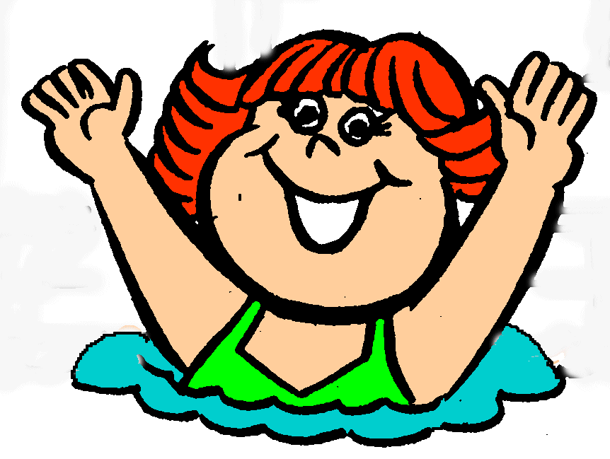
Can you swim? Can you skip a rope?
- Yes,I can. -No,I can't.

1- 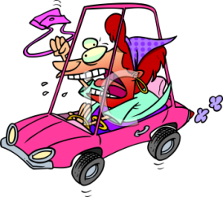 4- 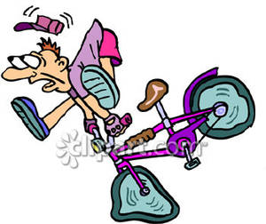
Can you drive a car? Can you ride a bike?
_______________ _______________

2- 5- 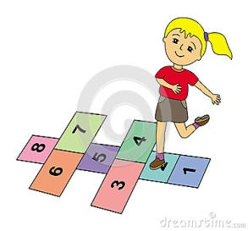
Can you play the piano? Can you play hopscotch?
________________ _________________

3- 6- 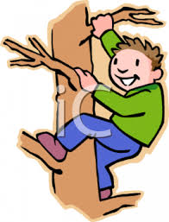
Can she run? Can you climb a tree?
________________ _________________

