Name: Date:
- Read and colour!
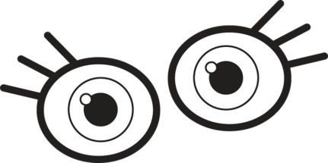
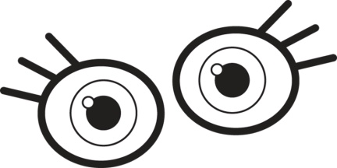

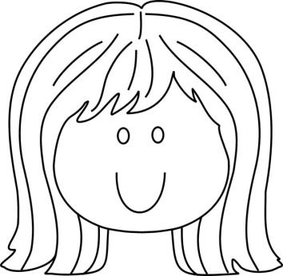
blue eyes brown eyes green eyes

blonde hair brown hair black hair
2. Read and draw!
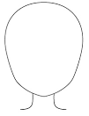

curly hair wavy hair straight hair
3. Read and draw!

fat

thin

tall

short

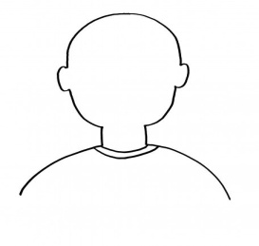

freckles

beard

moustache

